

KH-54, KH-55, KH-88, KH-G56, KH-G3128B with API (SDK) I/O Control Card
User Manual (Programming instructions are provided in a separate document)
Version 3.103
20200429 - Updated model selection instructions
20200506 - Added video tutorial links
20201016 - Added wiring diagram for 8 inputs and 8 outputs with high/low compatibility
20201207 - Added wiring diagram for 5 inputs and 6 outputs with high/low compatibility
20210120 - Added wiring diagram for 5 inputs and 4 outputs with high/low compatibility
20210120 - Added wiring diagram for 5 inputs and 5 outputs with
high/low compatibility
20240626 - Added 16 inputs and 16 outputs with PNP or NPN
model options

Contents
Introduction 1
I.Hardware Section 2
1.Overview 2
2.Hardware Information 5
3.Port Expansion 9
4.Product List 10
II. Software Section 10
1.Development Environment 11
2.Library Function List 11
3.QT Environment Configuration 14
4.VS Environment Configuration 15
5.Software Installation 16
6.Uninstall Software 17
7.Use the Virtual Card FAMIO_Virtual_Board to Simulate Hardware 17
8.Frequently Asked Questions 20

Introduction
With the advent of the Industry 4.0 era, I/O control cards are increasingly needed in various applications. In many cases, we require a moderate number of I/O ports, but most popular I/O expansion cards on the market come with dozens of ports and are quite expensive. In this context, FAMIO emerges as the solution!
FAMIO is characterized by its high speed, efficiency, safety, stability, and ease of learning, making it the best choice for projects requiring fewer ports!


Updates to the materials are subject to change without
notice. Please download from the cloud drive.
Link: https://pan.baidu.com/s/1J_yS1txisuBgo6-pMy745w
Access Code: q0gc


Link: https://pan.baidu.com/s/1Xy4mCTNFJFPYjO4R0QGDkA
Access Code: 5mvf


Link: https://pan.baidu.com/s/1syznKtgSQDrox389wtWnpQ
Access Code: oxd7

The content on the cloud drive is updated regularly,
so please check frequently to obtain the latest materials.
In addition to the cloud drive, video materials can be viewed online at the following URLs:
• 54 Card: https://v.qq.com/x/page/o0961ri16zm.html
• G56 Card: https://v.qq.com/x/page/x0961mgqal9.html
• 88 Card: https://v.qq.com/x/page/y0961ceygor.html
• G3128 Card: https://v.qq.com/x/page/d0961wgu0jy.html
• Light Source Controller: https://v.qq.com/x/page/k09618x42a4.html
Special Statement:
The copyright of this manual belongs to Shenzhen Foxage Co., Ltd. Without the written permission of the company, no one is allowed to reprint, translate, or copy any content of this manual.
The information in this manual is for reference only. Due to improvements in design and functionality, the company reserves the right to make the final interpretation of this material.

I.Hardware Section
Product Model Definition Rules:
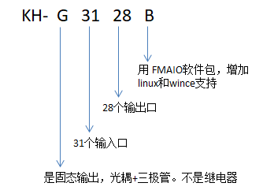
Models | Output Type | Communication Method | APP/SDK Package Name | Supported Systems | Description
KH-54B | Optocoupler + Relay | RS232 | FAMIO | Windows, WinCE, Linux
KH-G56B | Optocoupler + Transistor Amplification | RS232 | FAMIO | Windows, WinCE, Linux
KH-55B | Optocoupler + Relay | RS232 | FAMIO | Windows, WinCE, Linux | This model is built into the computer, making installation and wiring difficult
KH-88B | Optocoupler + Relay | RS232 | FAMIO | Windows, WinCE, Linux
KH-G3232B | Optocoupler + Transistor Amplification | RS232, RS485 | FAMIO | Windows, WinCE, Linux
KH-G1616B | Optocoupler + Transistor Amplification | RS232, RS485 | FAMIO | Windows, WinCE, Linux | Available in both high-level and low-level output versions
KH-54B |  | Optocoupler + Relay

1.Overview
Our company's IO card is a compact and flexible serial port I/O control card.
The specific appearance is shown in the following figures:

Figure 1.1.1: Appearance of the FAMIO Control Card (KH-54B)
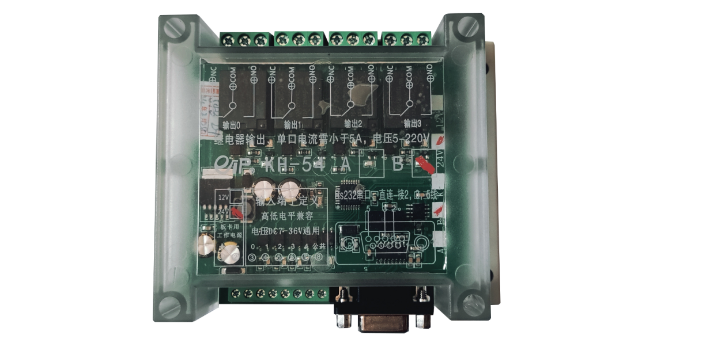
Figure 1.1.2: Appearance of the FAMIO Control Card KH-88B Upgrade Version: Compatible with High and Low-Level Inputs
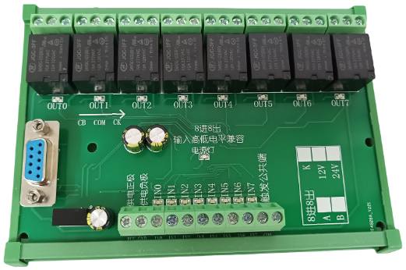

Figure 1.1.3: Appearance of the FAMIO Control Card KH-55

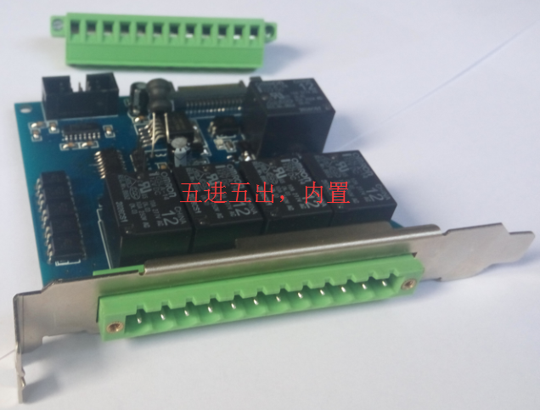
Figure 1.1.4: Appearance of the FAMIO Control Card KH-G56B
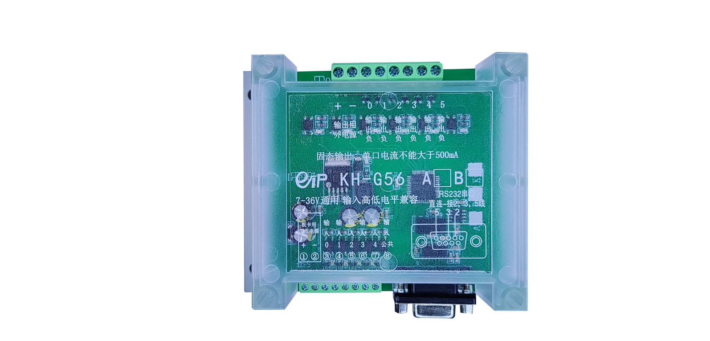
Figure 1.1.5: Appearance of the FAMIO Control Card KH-G3232B
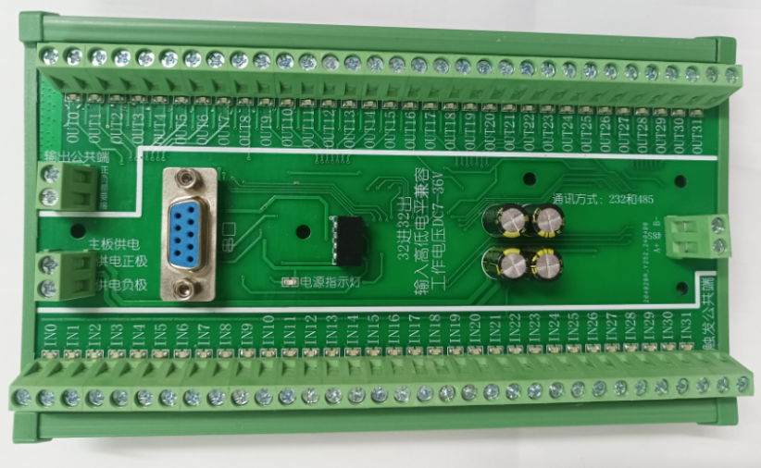

Figure 1.1.6 Appearance of the FAMIO Control Card KH-G1616B (Red arrows indicate the option for high-level or low-level output)
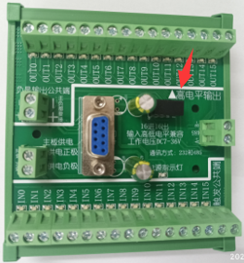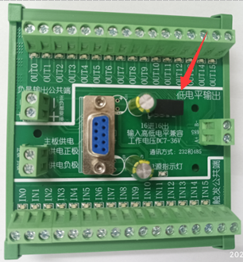
The hardware system block diagram of the IO control card is as follows: (Only the KH-G3128B model is equipped with both 485 and 232 serial ports)
Figure 1.1.7: Hardware System Block Diagram
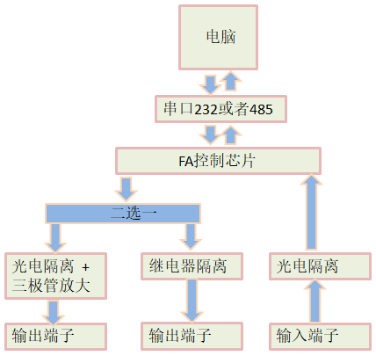

2.Hardware Information
Operating Voltage: DC 12V or 24V selectable.
Product Dimensions:：
KH-54B：115mm X 90mm X 40mm.
KH-88B：143mm X 98mm X 42mm.
KH-55B：82mm X 92mm X 20mm.
KH-G56B：115mm X 90mm X 40mm.
KH-G3232B：220mm X 98mm X 40mm.
Operating Temperature: -20°C to 70°C.
High and Low Levels:
- Effective level of board input signals: Compatible with high/low levels.
- When the common terminal is connected to the positive pole, the trigger signal input is connected to the negative signal. When the common terminal is connected to the negative pole, the trigger signal input is connected to the positive signal, as shown in Figure 1.2.1. (All models of IO card hardware have been upgraded to "input level high/low compatibility." For upgraded materials, please contact us or download from the cloud drive.)
Figure 1.2.1: Board Label
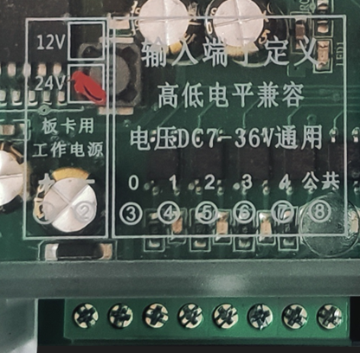
How to choose between low and high levels?
- If the sensor is NPN type, the signal end at 0V is a low-level input.
- If it is PNP type, the signal end at 24V or 12V is a high-level input.
Load Capacity:
For relay outputs, there are normally open and normally closed options, which can connect to 5~220V voltage, offering a wide range of applications.
For outputs with optocoupler and transistor, the load current for a single port should not exceed 500mA. However, if multiple ports output simultaneously, the total current should not exceed 3.5A. Different models may vary, so refer to the wiring diagram for details.
Interface Definition: See Figures 1.2.1, 1.2.2, 1.2.3, 1.2.4, 1.2.5, 1.2.6, 1.2.7 and 1.2.8.。
***Boards with input high/low level compatibility have independent circuits from the input and can use the same power supply or separate power supplies.***
Figure 1.2.2: KH-54B Upgrade Version Input High/Low Level Compatibility Interface Definition Diagram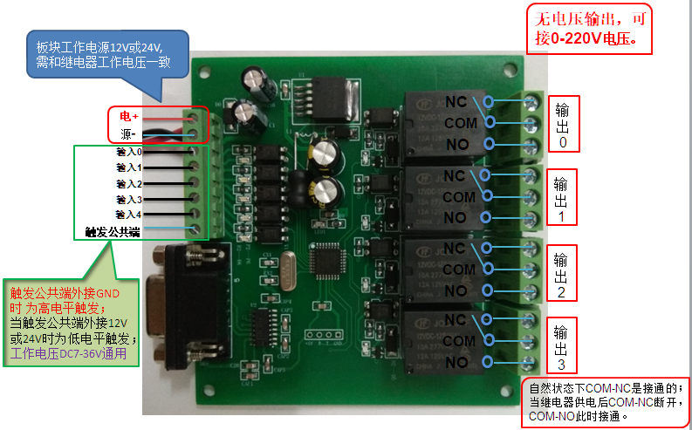

KH-88B/K has added input high/low level compatibility, with interface definitions as follows:
Figure 1.2.3: KH-88B/K Interface Definition Diagram
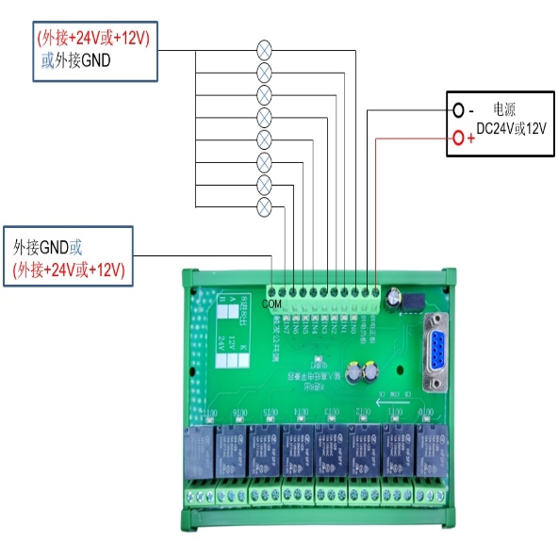

Figure 1.2.4: Output Terminal Wiring Method Diagram
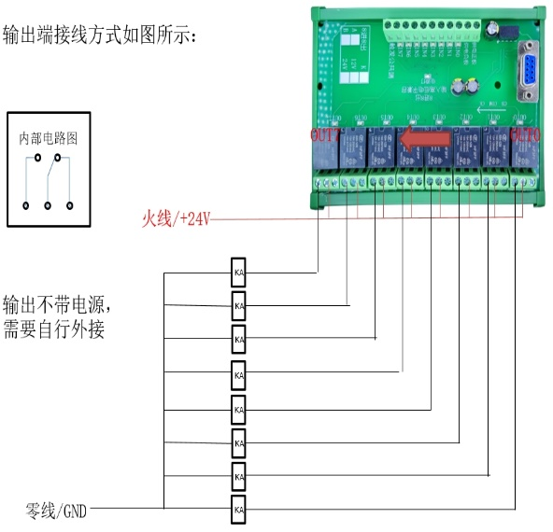
Figure 1.2.5: KH-55A/B Built-in Interface and Composition Diagram (Input High/Low Level Wiring Diagram)
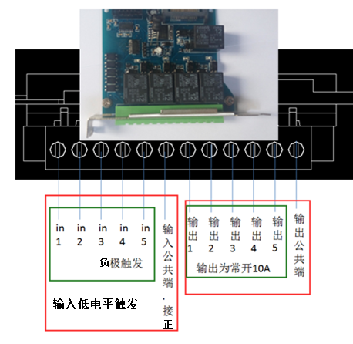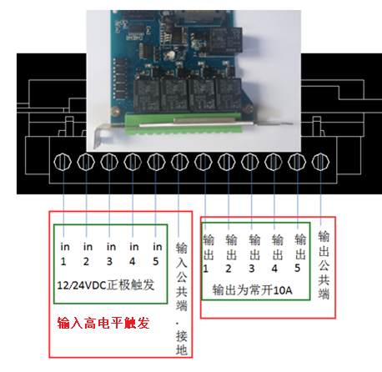

Figure 1.2.6: KH-55B Serial Port Socket Definition
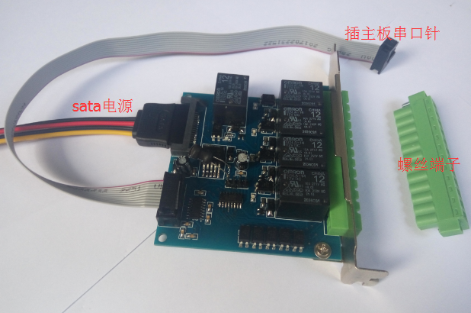

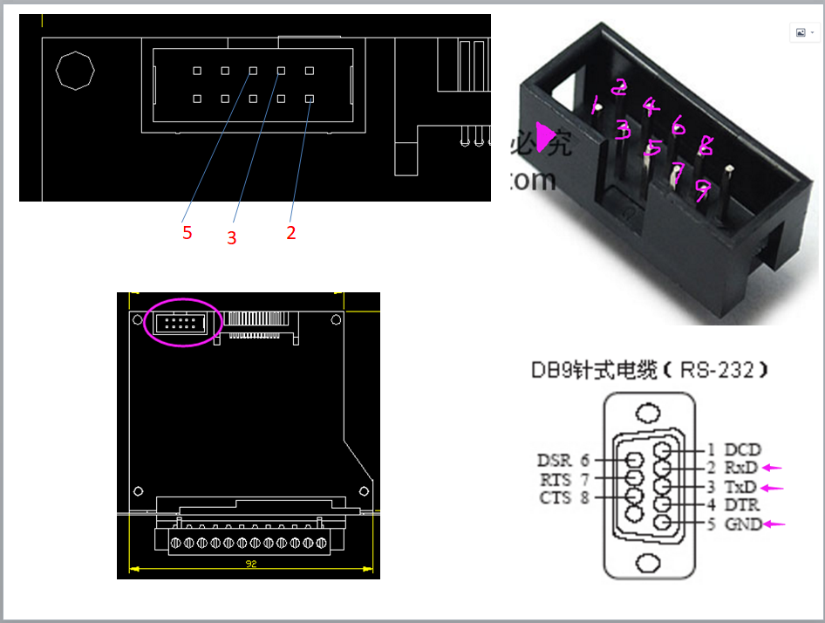

Figure 1.2.7: KH-G56A/B Added Input High/Low Level Compatibility Interface Diagram
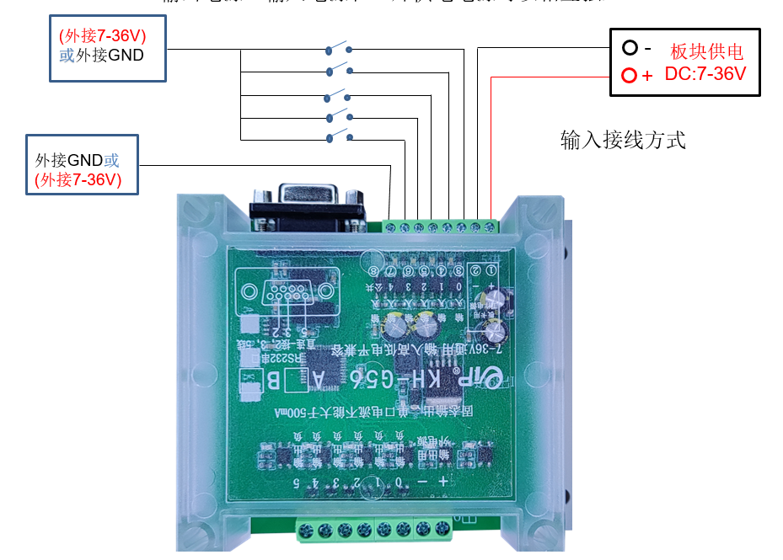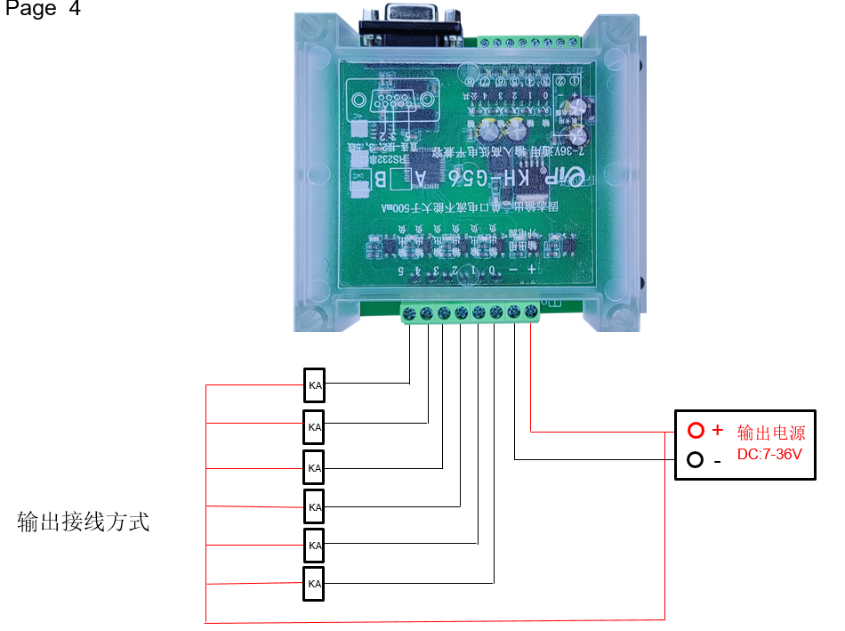
Note: For the KH-G3232B model, the maximum current for a single output port is 1.5A, and the total for all ports should not exceed 6A.
Figure 1.2.8: KH-G3232B Input High/Low Level Compatibility Interface Diagram
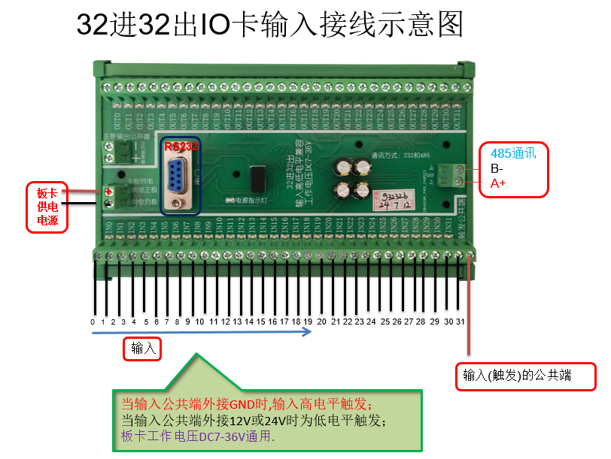
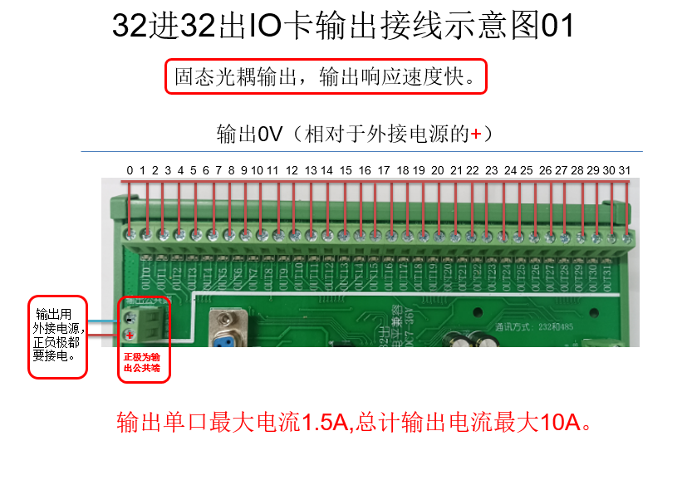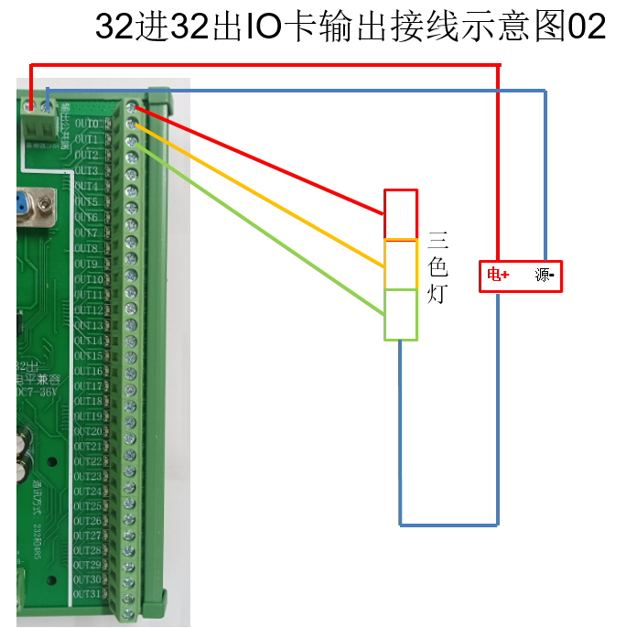

3.Port Expansion
- All FAMIO apps, demos, and virtual cards for testing are available for download from the cloud drive.
- Corresponding wiring (includes serial cable; direct connection to pins 2, 3, and 5).
The IO card relies on an independent serial port, and FAMIO cards can achieve multi-card parallel connections through multiple serial ports, as shown in Figure 1.3.1.
Figure 1.3.1: Parallel Connection Diagram of FAMIO Cards
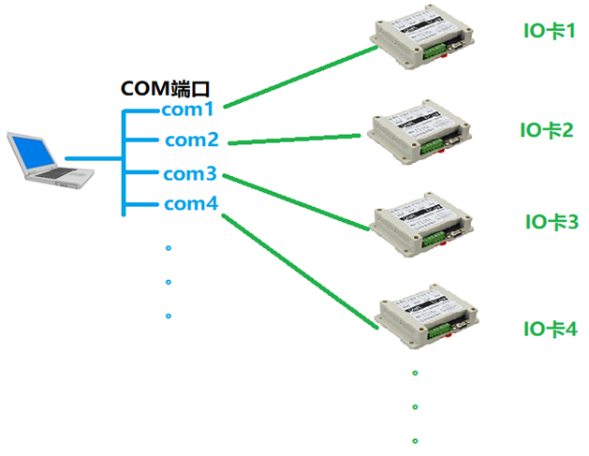
Note: FAMIO supports any port number. To view the COM port number, see Figure 1.3.2.
Figure 1.3.2: COM Port Numbers on the Current Computer
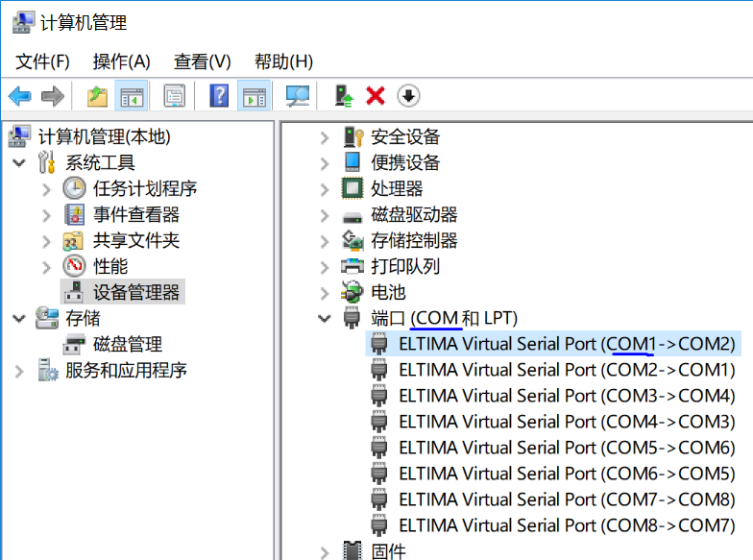

4.Product List
- All FAMIO apps, demos, and virtual cards for testing are available for download from the cloud drive.
- Corresponding wiring (includes serial cable; direct connection to pins 2, 3, and 5).

II. Software Section
FAMIO provides 22 basic functions and 3 extended functions for users, aimed at efficiently assisting users in secondary development. For details, refer to the FAMIO SDK.chm in the installation directory.
FAMIO also offers programming examples in languages such as VB, VB.net, C/C++, C#, LabView, Python, and QT. For details, see the demo section.
FAMIO supports both 32-bit and 64-bit programming development. Please pay attention to the version differences between 32-bit and 64-bit during development.
Function header files, module files, or definition files can be found in FAMIO.lib in the installation directory.
As shown in Figures 2.0.1 and 2.0.2:
Figure 2.0.1: Location of FAMIO.lib in the Installation Directory
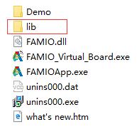

Figure 2.0.2: Files in FAMIO.lib
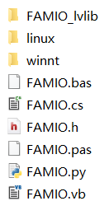

1.Development Environment
The FAMIO API library uses the standard C interface __stdcall calling convention:
(a) Supported Languages: All programming languages that support C interface DLLs.工作环境：所有(b) Operating Environment: All Windows operating systems from Windows XP onwards. (FAMIO also supports WinCE and Linux operating systems.)
(c) Thread Safety: All API functions, except for iolb_board_open and iolb_board_close, are thread-safe and can meet the requirements of multi-threaded development.

2.Library Function List
FAMIO provides a large number of practical library functions for development. The library function information is shown in Table 2.2.1:
Table 2.2.1: Library Function List
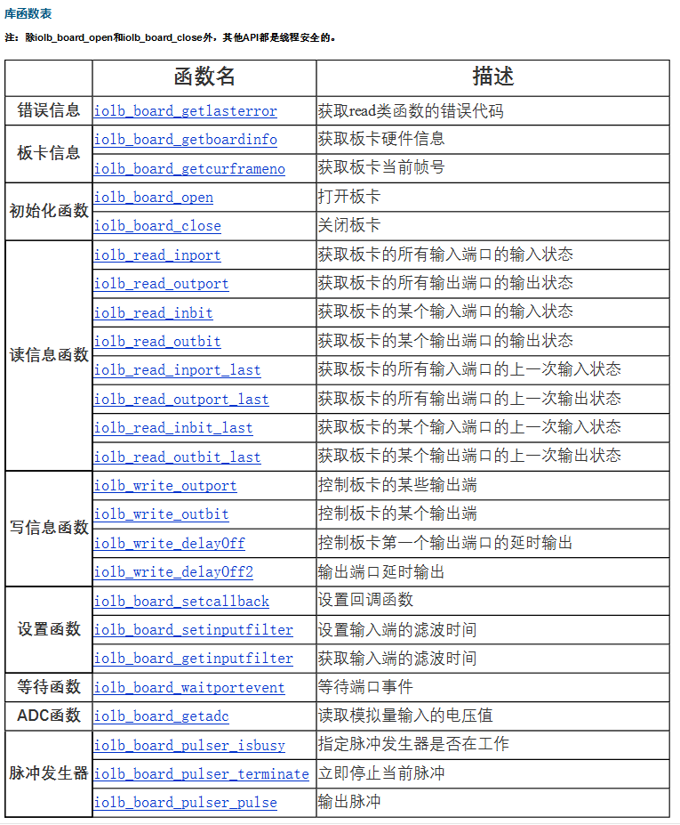

The FAMIO control card supports real-time port information retrieval through threads and callback functions. For details, see the demo.
- The flowchart for the thread method is shown below:

Figure 2.2.1: Flowchart of Thread Methods
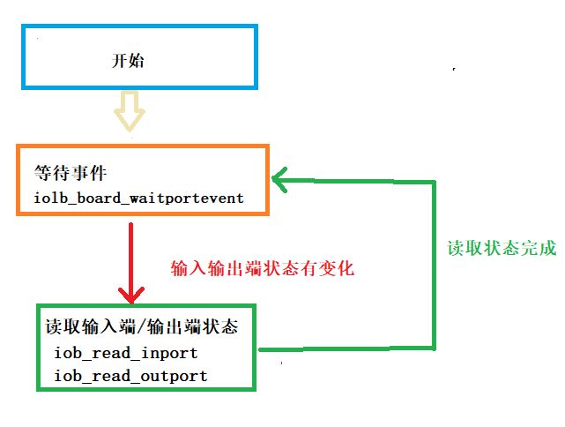
- Callback Method:

①Set the callback function (iolb_board_setcallback).
②Write the processing code within the callback function.
The system will enter the callback function when there is a change in the input/output port status.

Figure 2.2.1: Flowchart of the Thread Method
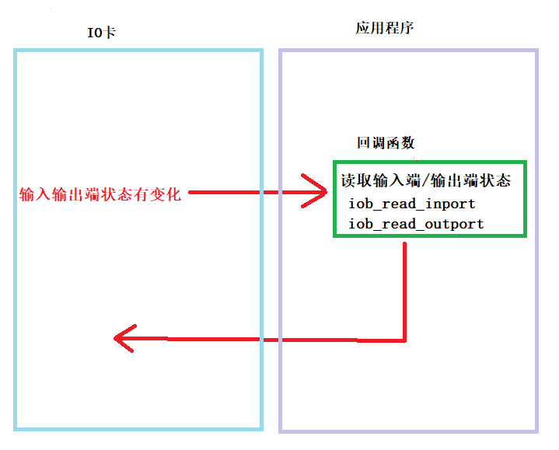

For details on both methods, refer to the demo files in the installation directory.
Note: When multiple input/output ports receive signals simultaneously, the callback function and iolb_board_waitportevent will only respond once. Compare the current input/output status with the previous status to determine which input/output ports have signals.

3.QT Environment Configuration
Using a 32-bit Windows system as an example:
① After installing FAMIOApp, add the library to the project's .pro file.
Figure 2.3.1: Configuration of FAMIO Library in QT Project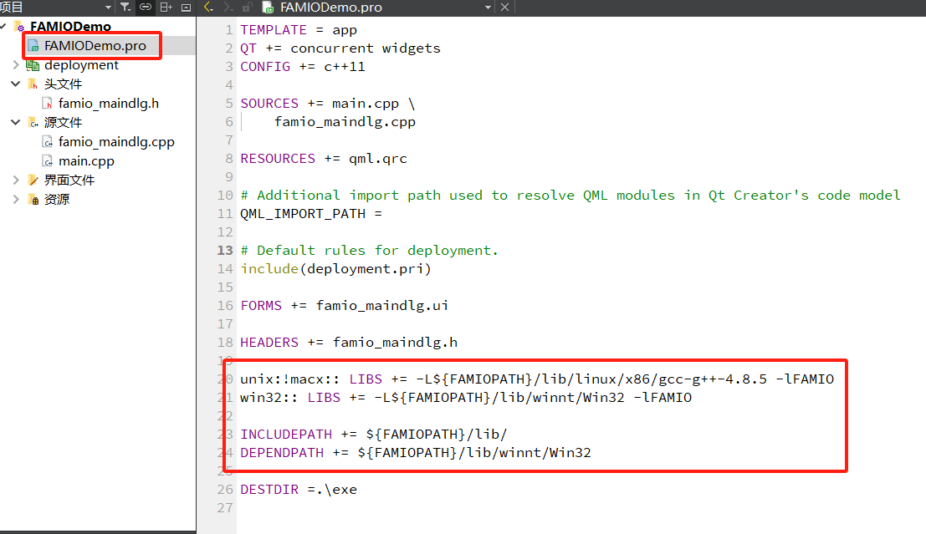

② Include FAMIO.h in the header file of the interface file.

Figure 2.3.2: Inclusion of FAMIO.h in the Project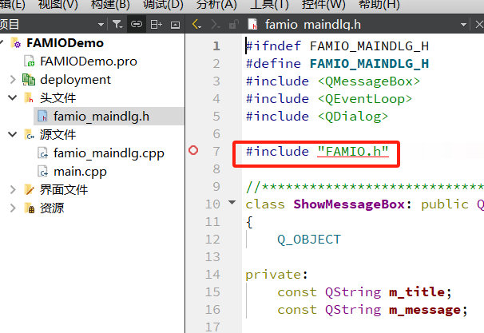

Note: The above configuration is based on qt-opensource-windows-x86-mingw492-5.6.2.

4.VS Environment Configuration
① Double-click the installation package 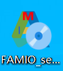and follow the prompts to install FAMIOApp.
② Configure the project environment as shown in Figures 2.4.1, 2.4.2, and 2.4.3:
Figure 2.4.1: C/C++ General Configuration
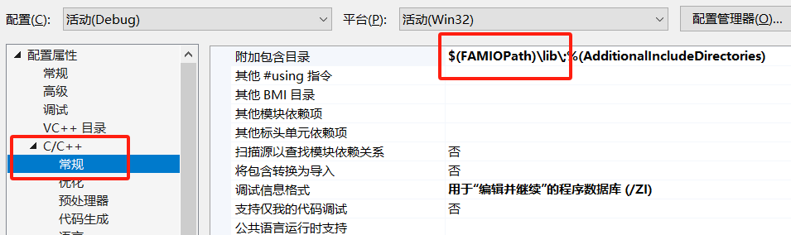
Figure 2.4.2: Linker General Configuration
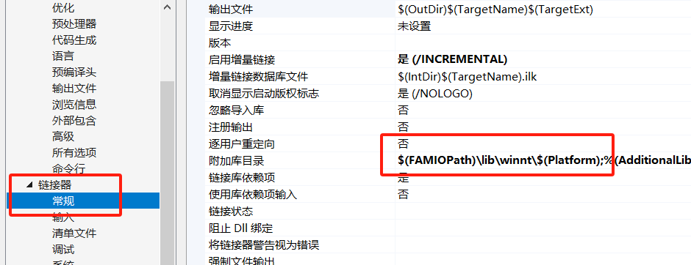
Figure 2.4.3: Linker Input Configuration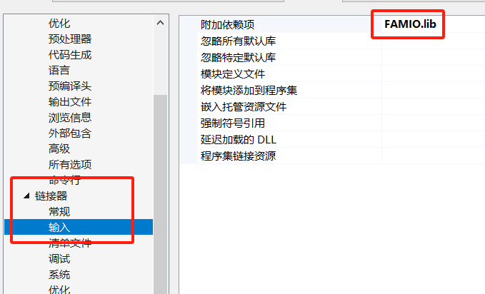

5.Software Installation
Download from the Baidu Cloud link provided at the beginning of the manual, and double-click to install.
Figure 2.5.1: Installing FAMIO
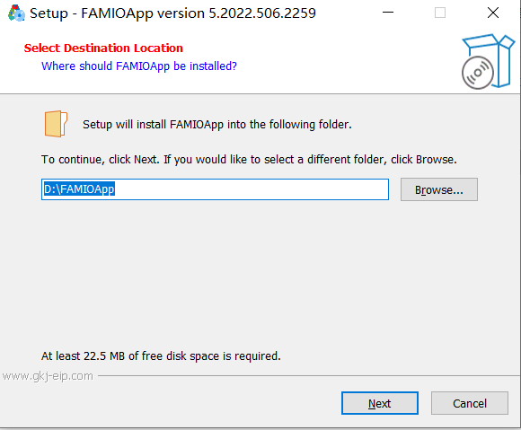

After installation, all FAMIO resources can be found in the "Start" menu -> "All Programs" on the computer.
Figure 2.5.2: FAMIOApp Installed Resources
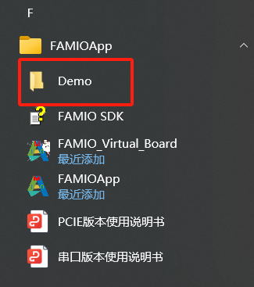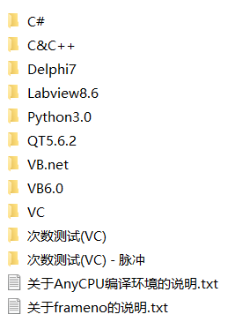

6.Uninstall Software
Find it in the Start menu and double-click to uninstall FAMIOApp.
Figure 2.6.1: Uninstalling FAMIO
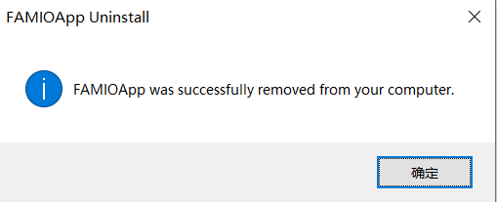

7.Use the Virtual Card FAMIO_Virtual_Board to Simulate Hardware
When you do not have KH-54B, KH-88B, KH-55B, KH-G56B, KH-G3128B serial I/O control cards at hand, you can simulate these serial I/O control cards using the virtual card. The specific method can be divided into the following three steps:

- Use virtual serial port software to create a pair of virtual serial ports.
Figure 2.7.1: Virtual Serial Port
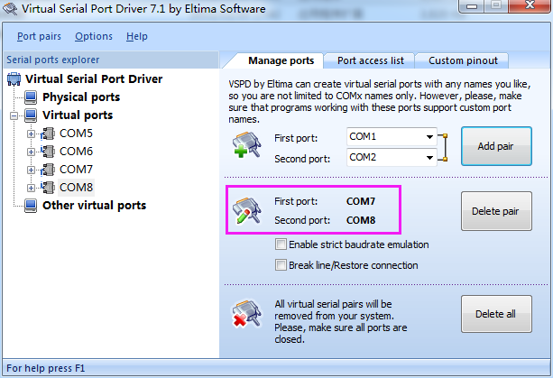

- Open the virtual card FAMIO_Virtual_Board, enter the serial port number (the first port of the virtual COM port pair created by the virtual serial port software, as shown as 7 in Figure 2.7.2), and click the "Open" button.
Figure 2.7.2: Virtual Card Opening Interface
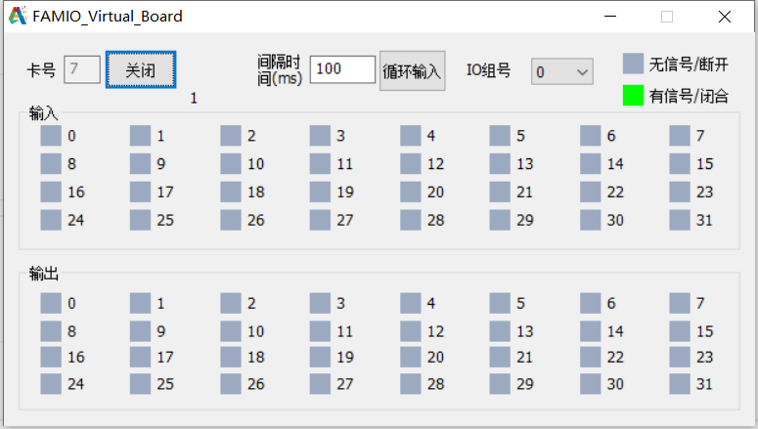

- Open FAMIOApp.exe, select the board number (the second port of the virtual COM port pair created by the virtual serial port software, as shown as 8 in Figure 2.7.3), and click the "Open" button.
Figure 2.7.3: FAMIO Start and Operation Interface
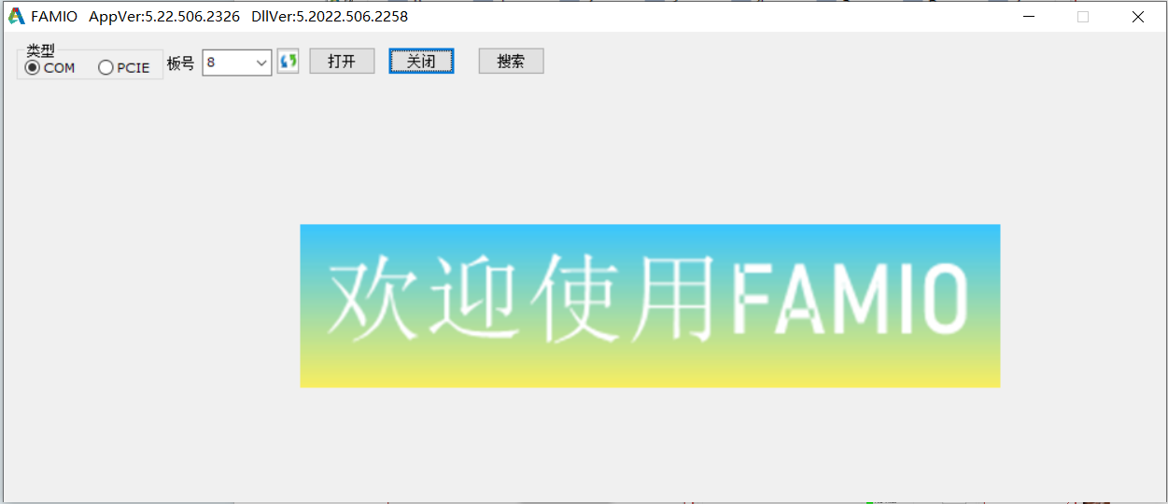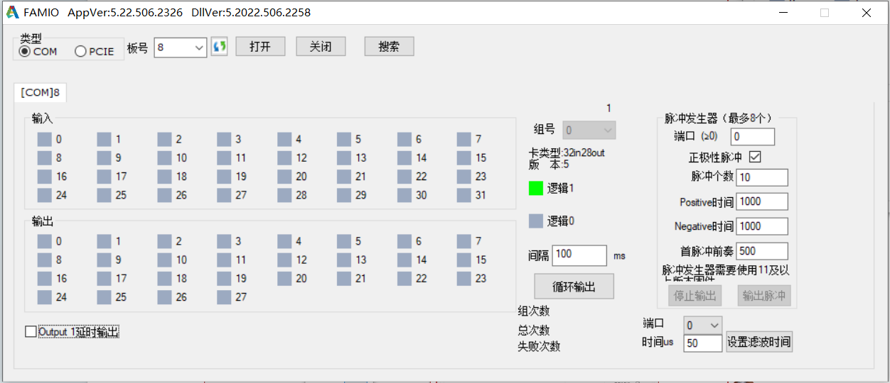

- FAMIOApp New Search Board Function: Press the "Search" button to display the serial port numbers connected to the board. Select the board number (example board number is 8), and click the "Open" button, as shown below:
Figure 2.7.4: FAMIO Start and Operation Interface
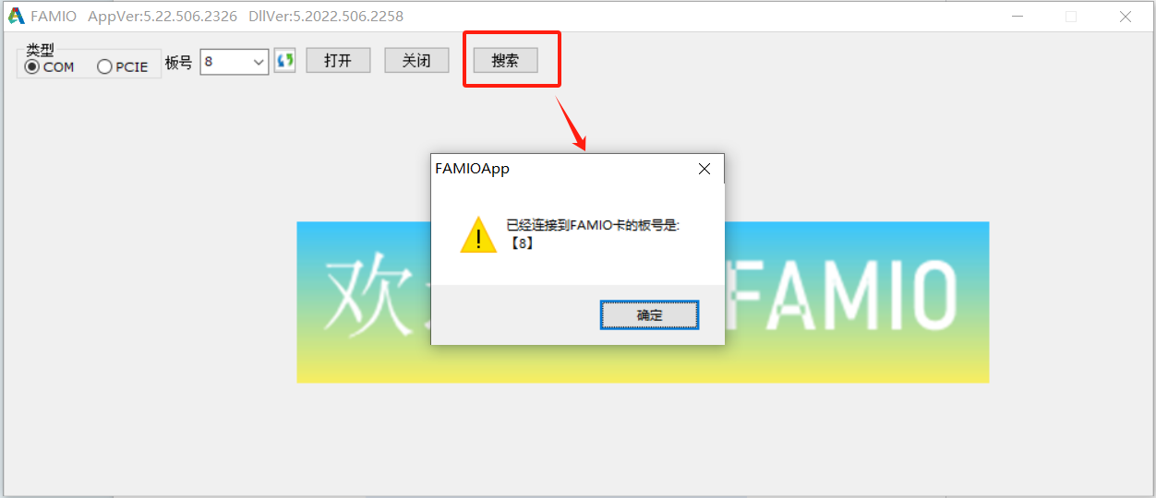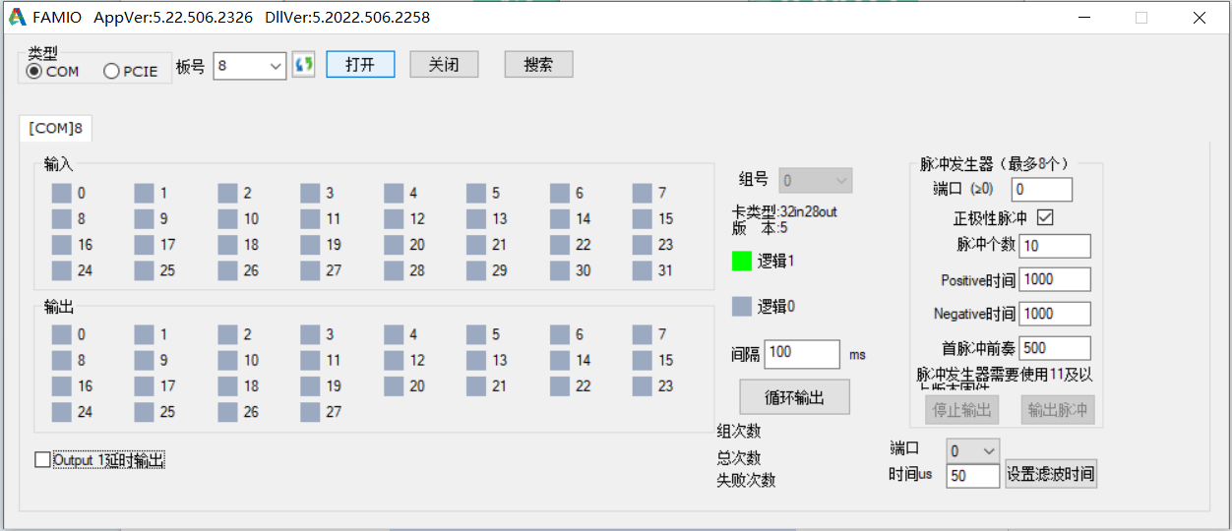
If you are programming using the SDK, you can skip this step. With the virtual card, you can quickly complete the debugging and development of the I/O section without the limitations of FAMIO hardware.
Note: Do not check the red box shown in Figure 2.7.4 in the serial port settings. Otherwise, there may be an error in the virtual card status.
Figure 2.7.5: Virtual Serial Port Setting Note
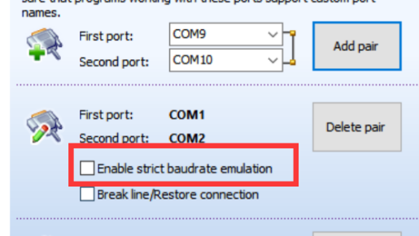

8.Frequently Asked Questions
Q1: No card number appears in the dropdown selection box after opening FAMIO.
A1: The board number shows the serial port numbers that can be opened by the current system. If the serial port is already open or does not exist, it will not be displayed. Alternatively, you can directly enter the serial port number in the dropdown selection box.

Q2: "Wrong card" error appears when opening FAMIO.
A2: Check if the serial port number connected to the board is correct. If using a virtual card, ensure the virtual card is open and the serial port number is correct.
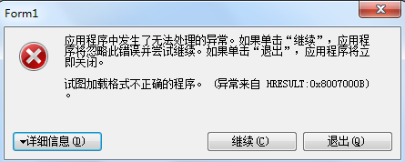
Q3: When using .NET programming, the program displays the interface shown on the right:

A3: The version of FAMIO.dll being used is incorrect. FAMIO.dll has 32-bit (x86) and 64-bit (x64) versions. Please ensure you are using the correct version.

Q4: Does FAMIOApp support Linux systems?
A4: Yes, it does. We can run it on Linux using the .image method. Please contact customer service if needed.

Q5：How to write a program to send pulses?
A5: The new version (2017) of FAMIO provides three extended functions for pulse generation, which can be used to send pulses. If you are using the new version (2017) of FAMIO, you can download the latest version of the software from the website, where the demo provides detailed instructions.

Q6: Does it support VB or VB.net, and can it support QT and LabView?
A6: FAMIO's API functions use the standard C interface stdcall method, theoretically supporting all programming languages that support standard DLLs. Therefore, VB, VB.net, QT, and LabView are all supported.

Q7: After configuring the VS environment as per the manual, FAMIO.h and other files are still not found.
A7: Reinstall FAMIOApp. The Release in the examples does not configure the relevant environment. If configuration is needed, please follow the VS environment configuration as described in the manual.

Q8: Does the FAMIO card only support Windows systems? Can it support Unix, Linux, iOS, and other systems?
A8: FAMIO currently supports Windows, WinCE, and Linux systems.

If you encounter other issues during use, you can call the technical support hotline at the footer (for quick support) or send questions or suggestions to the email 410795858@qq.com. We will do our best to provide you with the highest quality technical service.

