KH-FL04A Light Source Controller User Manual Z0.10

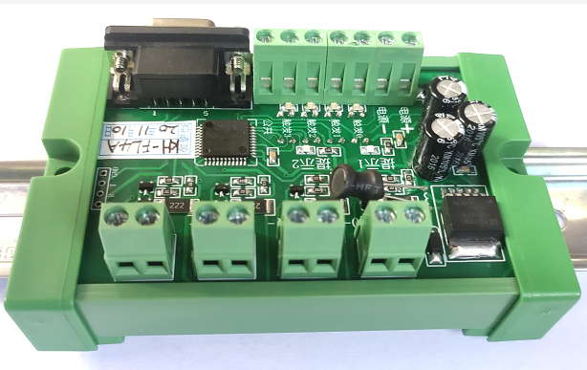

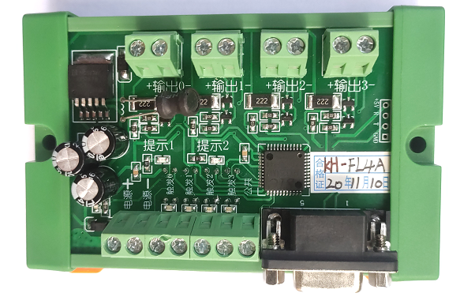

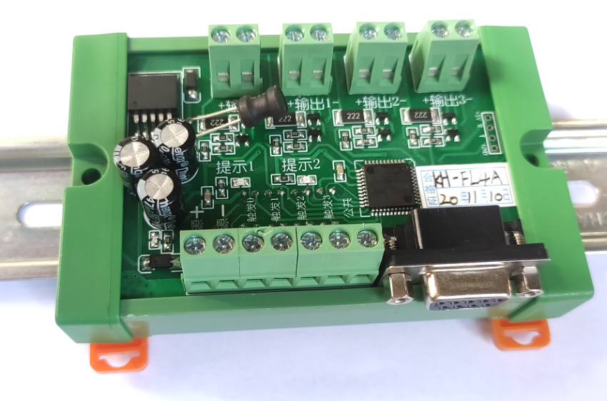

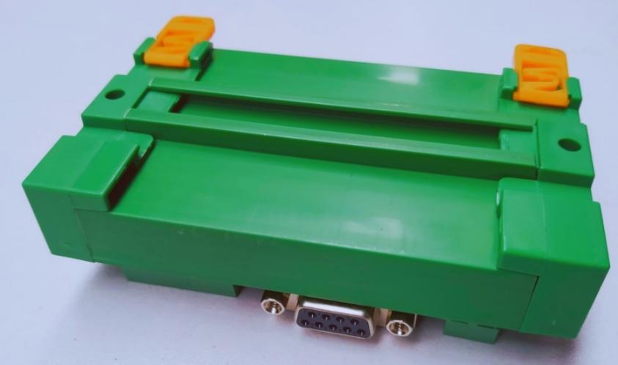

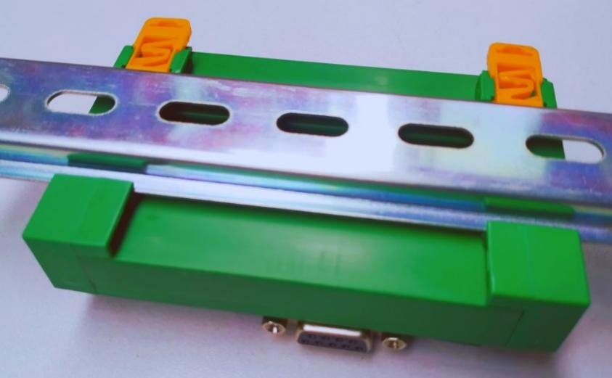

**1,Overview**

The KH-FL04A light source controller is designed to drive four channels of light sources, offering 255 levels of brightness adjustment (0-255). It features a strobe mode with pulse width brightness ranging from 0 to 9999ms, which can be controlled via a panel or serial communication. The external trigger uses high-speed optocoupler isolation to provide accurate and reliable trigger signals, preventing false triggers due to environmental vibrations. It supports both high and low-level triggering. The controller also includes a power-off memory function and is characterized by high power, fast response, high stability, and consistent strobe brightness.

**2,Technical Specifications**

|  |  |
| --- | --- |
| ****Model**** | KH-FL04A |
| ****Power Supply**** | External 24V (some lights use 12V). |
| ****Output Voltage**** | Consistent with the power supply. |
| ****Total Output Current**** | Each channel can independently output 2A, without sharing current. |
| ****Channels**** | 4 channels. |
| ****Brightness Control Method**** | Controlled via Windows application software or serial communication. |
| ****External Trigger Interface**** | Active trigger with switchable high and low-level triggering. |
| ****External Trigger Voltage**** | Effective trigger voltage: 7-36V DC. |
| ****Operating Environment**** | Windows 7 or Windows 10 |
| ****Maximum Dimensions**** | 10.5 x 7.3 x 3 cm. |
| ****Usage Environment**** | Inside a distribution box, product. |

========================================================================

**3,External Trigger Terminal Definition**

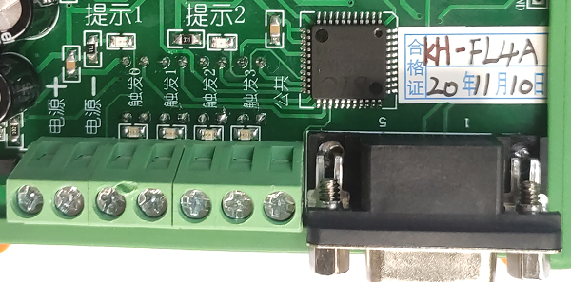

|  |  |
| --- | --- |
| ****Port**** | ****Port Definition**** |
| **＋**(Positive)**** | This is the main power supply positive terminal for the controller, which can be either 24V or 12V, matching the working voltage of the light source (most lights use 24V). |
| **－**(Negative)**** | This is the main power supply negative terminal for the controller. |
| ****Trigger 0**** | External trigger input 0. |
| ****Trigger 1**** | External trigger input 1. |
| ****Trigger 2**** | External trigger input 2. |
| ****Trigger 3**** | External trigger input 3. |
| ****Common**** | Common terminal for triggers. |
| ****RS-232**** | RS232 communication port. |

-----------------------------------------------------------------------

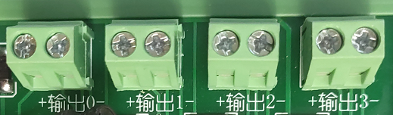

|  |  |  |
| --- | --- | --- |
| ****Port**** | ****Port Definition**** | Channel names can be customized through the APP |
| ****Output 0**** | Channel 0 Output | As shown, this channel is defined as: Positioning Light |
| ****Output 1**** | Channel 1 Output | As shown, this channel is defined as: Detection Light |
| ****Output 2**** | Channel 2 Output | Click on Channel 2 to manually change the name |
| ****Output 3**** | Channel 3 Output | Click on Channel 3 to manually change the name |

**The interface of the light source controller's APP allows for manual renaming of channel names, as illustrated in the example image:**

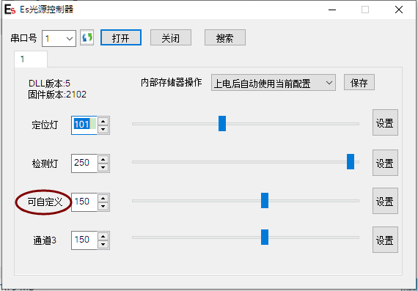

**--------------------------------------------------------------------------------------------------------------**

**APP New feature:**

1,The KH-FL04A light source controller's APP includes a feature that allows users to click "Search" on the interface. When this option is selected, all detected light source controllers are simultaneously activated. In the provided example, the connected light source controllers have serial port numbers 10 and 1. This functionality is designed to streamline the process of managing multiple controllers by enabling users to quickly identify and access all connected devices through the APP interface. This feature enhances the usability of the system by allowing for efficient control and operation of multiple light sources.

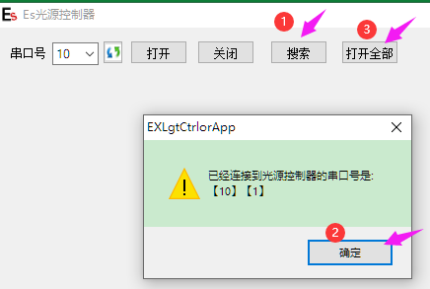

After completing the three steps in sequence as shown in the previous illustration, the APP will display that two light source controllers have been activated. This indicates that the controllers are successfully connected and operational, allowing users to proceed with further customization or control tasks as needed. The interface will reflect the active status of the controllers, making it easier to manage and distinguish between different devices.

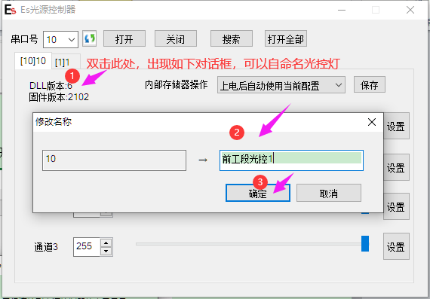

Upon entering the specified interface in the APP, users can customize the names of the light source controllers. This feature is designed to help users easily distinguish which controller is managing which section of the operation. The process for changing the names involves three steps, as illustrated in the referenced diagram. Once these steps are completed, the updated names will be displayed, allowing for clearer identification and management of the controllers. This customization is particularly useful in environments where multiple controllers are in use, ensuring that each one can be easily identified and associated with its specific function or location.

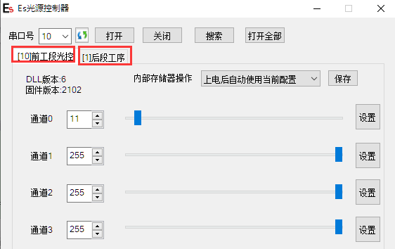

The context provided describes the functionality of the KH-FL04A light source controller and its APP. Specifically, it mentions that when you customize the names of the light source controllers through the APP, these changes are automatically saved in an .ini file. This file is generated by the APP and contains the current configuration settings, including the customized channel names. When you open this .ini file, you can see the updated settings as illustrated in the referenced diagram. This feature ensures that any changes made to the controller settings are preserved, even after the APP is closed or the controller is powered off and on again, provided the same computer is used.

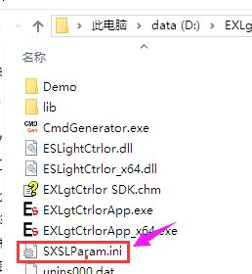 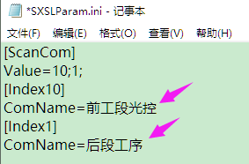

**The KH-FL04A light source controller's APP includes a feature that automatically saves the current parameter settings when the APP is closed. This means that once you have configured the desired parameters within the APP, these settings are preserved even if the light source controller is powered off and then powered back on. Upon restarting, the controller will automatically apply the previously set parameters, provided that the same computer is used. This functionality ensures that users do not need to reconfigure the settings each time the controller is restarted, enhancing convenience and efficiency in managing the light source controllers.**

2，多张卡使用时，出现了类似呼吸节奏的灯光明暗变化的情况（简称呼吸闪，下同），可以使用app的“呼吸闪优化”功能。

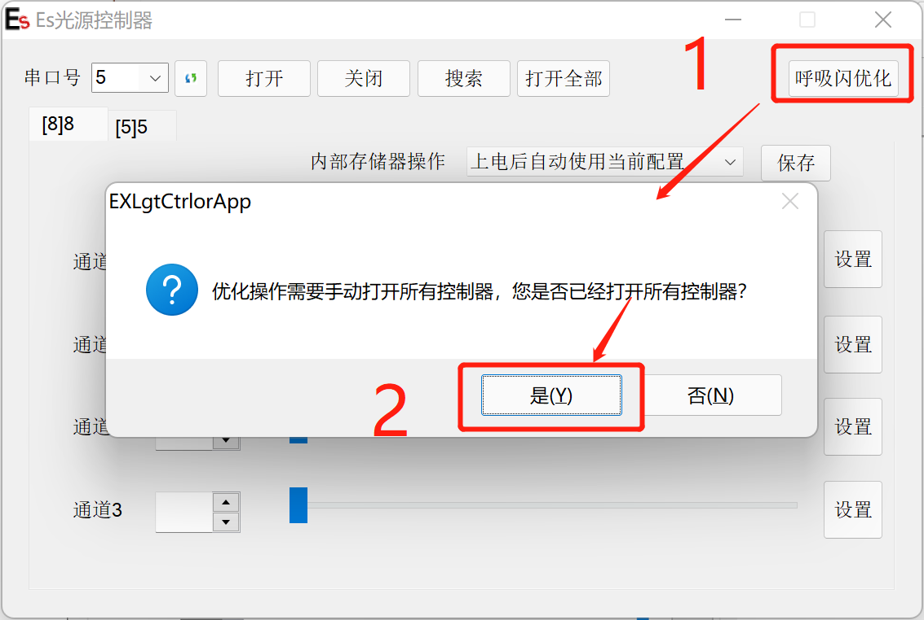

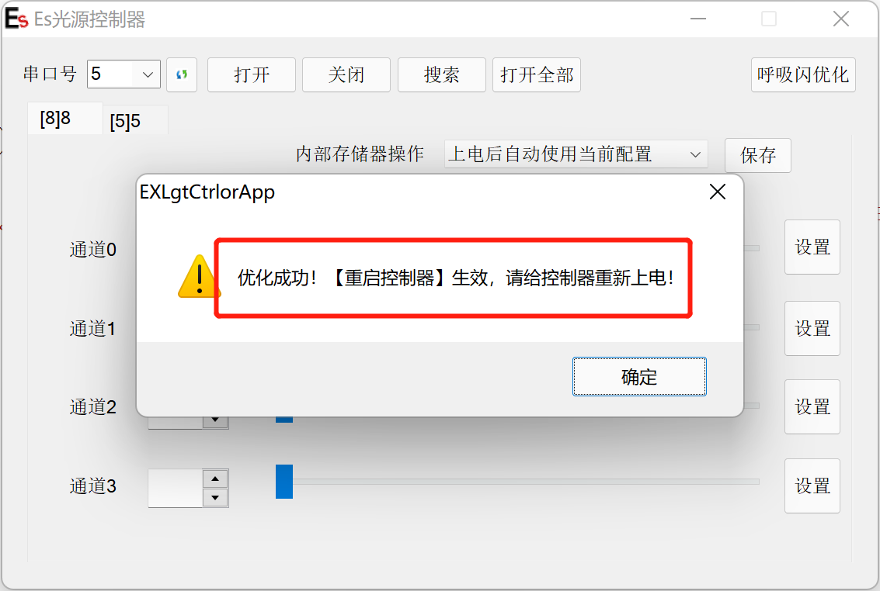

**When using multiple light source controllers (referred to as "cards"), you may encounter a situation where the lights exhibit a breathing-like rhythm of brightness changes, known as "breathing flash." To address this issue, the APP provides a "Breathing Flash Optimization" feature. Here are the steps and considerations for using this function:**

**①Ensure All Controllers Are Open: Before using the optimization feature, make sure that all connected controllers are successfully opened in the APP.**

**②Restart Controllers After Optimization: Once the optimization is successfully applied, you need to restart the controllers. This involves powering them off and then back on.**

**③Firmware and DLL Version Requirements: The firmware version of the controllers must be 2103 or higher, and the DLL version must be 7 or higher to use this feature effectively.**

**By following these steps, you can mitigate the breathing flash effect and ensure stable light output across multiple controllers.**

**4，通讯控制（软件工程师看）Communication Control (For Software Engineers)**

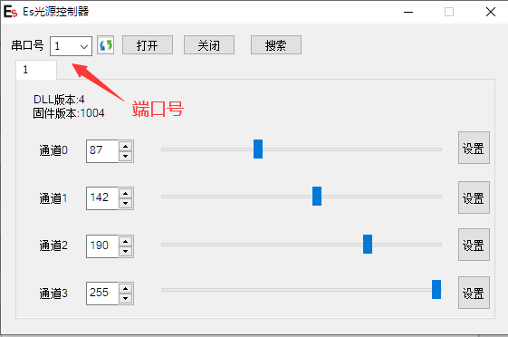

Click the "Settings" button on the right side of the diagram to select the operating modes for channels 0-3, as shown in the diagram below.

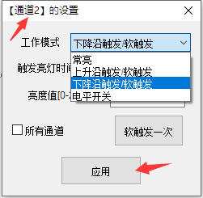 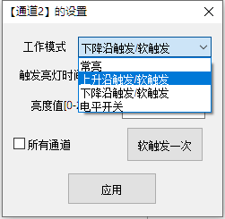

**Part of the agreement: After installing the app, open the "Command Generator" within the application.**

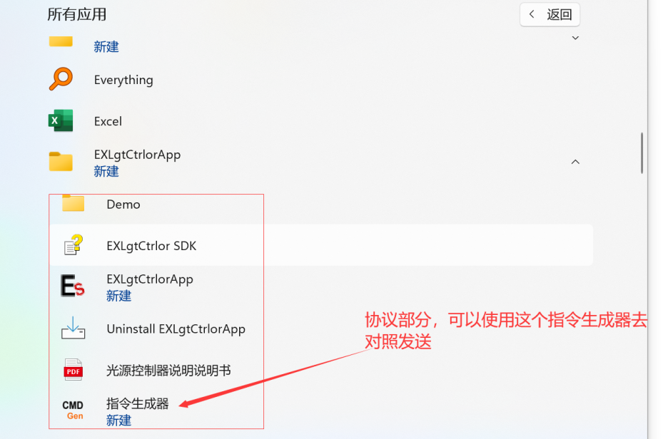

You can obtain the set instruction diagrams from the instruction generator.

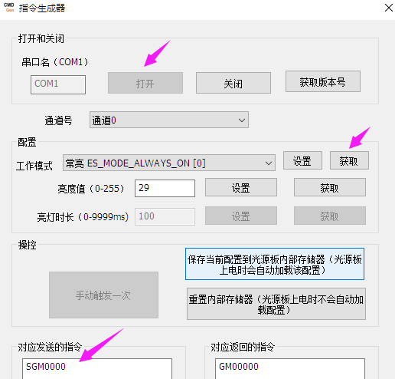

**5,Wiring Diagram (For Electrical Engineers)**

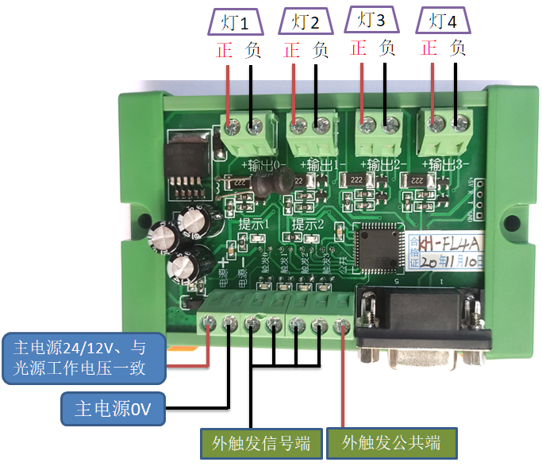

**6,长*宽*高10.5*7.3*3cmProduct dimensions (structural engineer): Length*Width*Height 10.5*7.3*3 cm**

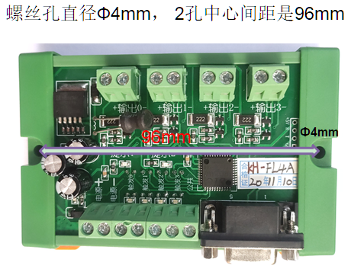

**7,Notes:**

When using the strobe function, it's necessary to set different external trigger delays for different cameras, with a delay of approximately 2ms, to prevent unstable lighting from affecting the quality of the captured images.

**8,Advantages:**

**\*Indicator Lights:**

When the microcontroller is operating normally, LED1 is on; when switching work modes, LED2 flashes.

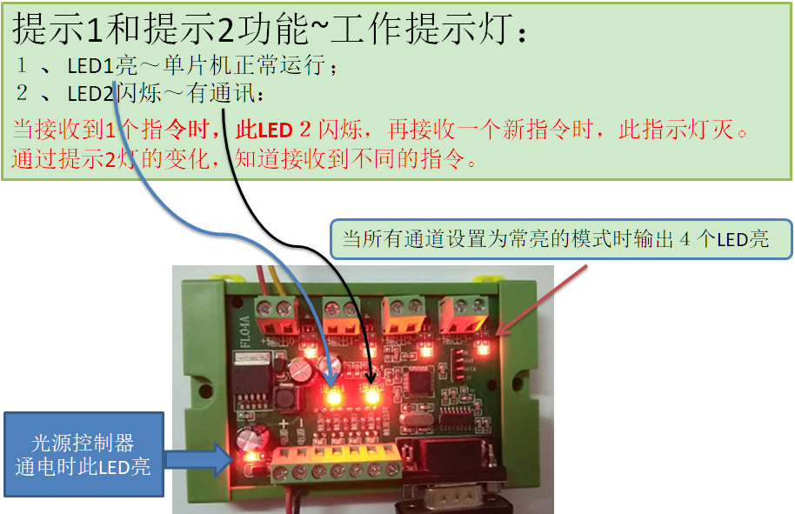

**\*Multiple light source controllers can be used simultaneously!**

An example diagram of connecting 2 light controllers is shown below (the connected serial port numbers are 9 and 1):



