视觉计数包装机规格书

该设备用于对各种物品进行计数并完成包装。通过高分辨率摄像头捕捉产品图像，利用软件算法进行精准计数，然后进行自动包装。视觉计数包装机广泛应用于食品、电子元件、小五金配件、玩具颗粒、种子等物品的包装，能够显著提高生产效率，减少人力成本，并保证产品包装的质量和准确性。全套配置的设备的模块包括上料、视觉计数和筒膜包装三个部分，适用于3C电子、橡塑、食品、制药等行业。该视觉计数包装机采用先进技术，无需人工干预，能够自动检测产品数量。当达到设定数量时，会立即发出包装指令，完成一次性包装任务。

The device is used for counting various items and completing packaging. It captures product images using a high-resolution-line-scan camera, utilizes software algorithms for precise counting, and then performs automatic packaging. The vision counting and packaging machine is widely used for packaging items like food, electronic components, small hardware parts, toy pellets, and seeds. It can significantly improve production efficiency, reduce labor costs, and ensure the quality and accuracy of product packaging. The fully configured device includes modules for feeding, vision counting, and film tube packaging, making it suitable for industries such as 3C field electronics, rubber and plastics, food, and pharmaceuticals. This vision counting and packaging machine employs advanced technology and requires no manual intervention. It can automatically detect the product quantity and, upon reaching the set quantity, immediately issue packaging instructions to complete a one-time packaging task.

产品特色：

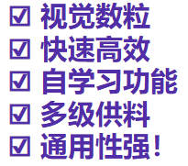

视觉数粒  
快速高效  
自学习功能  
多级供料  
通用性强！

• Visual Particle Counting System  
• High Speed and Efficiency  
• Auto-learning Capability  
• Multi-tier Feeding System  
• Wide Application Range!

电源:220VAC，如果是其他电压适配电压转换器。

承重:100KG以上

高度:880mm-1800，不同型号高度不同。

速度:6000pcs/min(以M3螺丝为例)产品越大，速度越低。

检测尺寸:2mm-100mm

计数精度:千分之二到万分之五，之多不少。看物料是否容易打散而定。

高速精准，具有一键自动学习功能，人员操作简单。

适用于各种铸件，紧固件，及塑胶件的出库点数和采购部品的入库验收点数，避免生产流程中点数不准造成的浪费及生产不可控。

设备功能分类：定量计数，按照指令数量清点，够了停机。不定量计数，倒入料槽的清点一下总数。

Power Supply: 220VAC, voltage converter available for other voltage requirements.  
Load Capacity: Over 100KG  
Height: 880mm-1800mm, different models have different heights.  
Speed: 6000pcs/min (using M3 screws as example), larger products result in lower speeds.  
Detection Size: 2mm-100mm  
Counting Accuracy: 0.2% to 0.05%, more is acceptable but never less. Accuracy depends on how easily materials can be separated.  
High-speed and precise, with one-key auto-learning function, easy for operators to use.  
Suitable for counting outgoing castings, fasteners, and plastic parts, as well as incoming inspection counting for purchased components, preventing waste and uncontrollable production caused by inaccurate counting in manufacturing process.  
Equipment Function Kind: Fixed quantity counting, counts according to preset quantity and stops when reached. Variable quantity counting, counts total quantity of items poured into feeding trough.

下面的图是可以计数的产品举例：

Below are examples of products that can be counted:

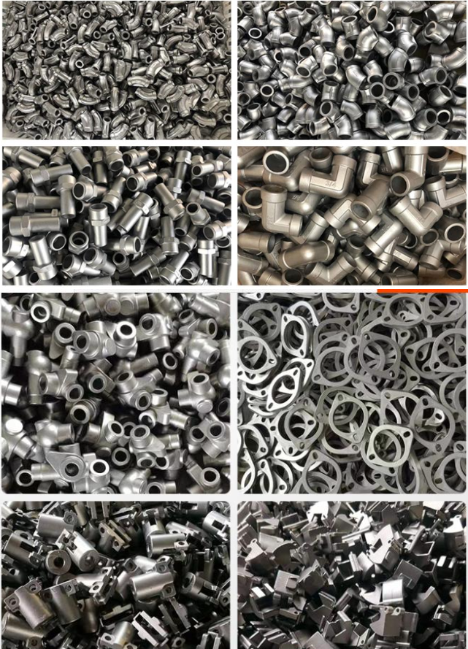

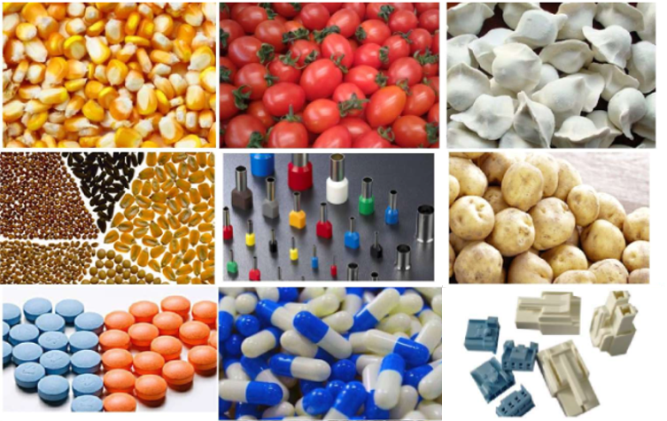

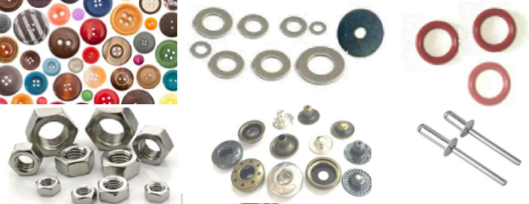

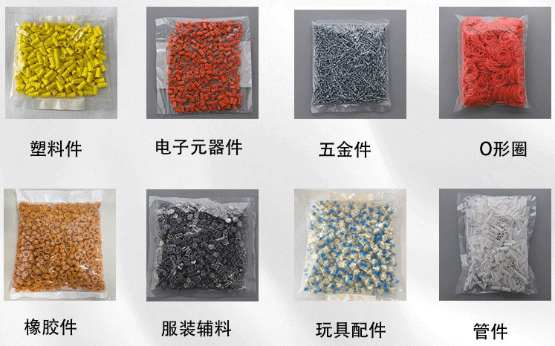

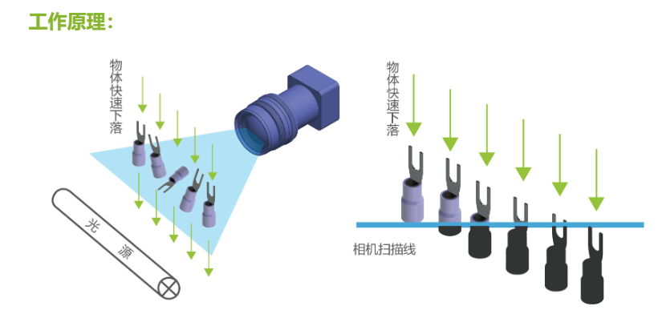

视觉计数设备的计算原理：搭配高速工业线阵相机，当物料下落经过相机识别区域时，线阵相机通过高速扫描，精准捕捉物料下落姿态、形状等信息，并上传至处理中心，通过处理中心强大算法实时分析处理，精准计算出物料个数，实现实时计数功能。

Operating Principle of Visual Counting Equipment:

The system is equipped with a high-speed industrial line scan camera. When materials fall through the camera's detection zone, the line scan camera performs high-speed scanning to precisely capture information such as falling posture and shape of the materials. This data is uploaded to the processing center, where powerful algorithms analyze and process it in real-time. The processing center accurately calculates the number of items, enabling real-time counting functionality.