Delta Robot Plating Machine

Perspective structural description, using 350 work radius as an example:

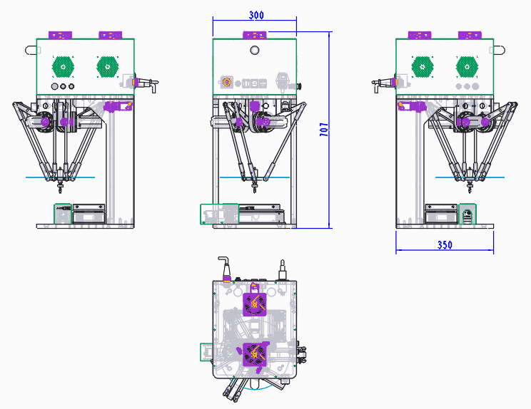

=====共4款，下面详细描述每个不同型号=====

**Model: FA-ZPD250A**

Below is the product introduction and product image:  
**Optical System**: 2 sets of vision systems (flexible vibration bowl positioning camera + fly-by camera)  
**Delta Robot**: 250 mm arm length, 0.3 kg load capacity  
**Vibration Bowl Size**: dimensions 150 x 100 mm  
**Refilling Bin Capacity**: 2L horizontal flow refilling bin  
**Number of Suction Cups**: 1  
**Control System**: Proprietary integrated control system of robotic, vision, and flexible vibration bowl systems  
**Plating Speed**: 3000 to 4500 pieces per hour, depending on product size and front-end vibration bowl differences (plating speed does not include debugging time)  
**Plating Precision**: Without fly-by: ±0.2 mm, With fly-by: ±0.05 mm  
**Plating Size**: 150 x 100 mm  
**Tray Loading Method**: Manual loading and unloading of trays  
**Power Configuration**: 220V, 50Hz, power: 2kW (110 to 220V converters available)  
**Air Pressure**: 0.35 to 0.7 MPa  
**Device Weight**: 300 kg  
**Equipment Dimensions**: 537 mm (length) × 225 mm (width) × 636 mm (height)  
**Operating Temperature**: 0°C to 50°C

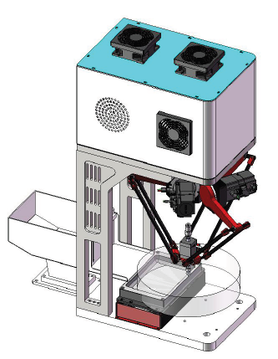

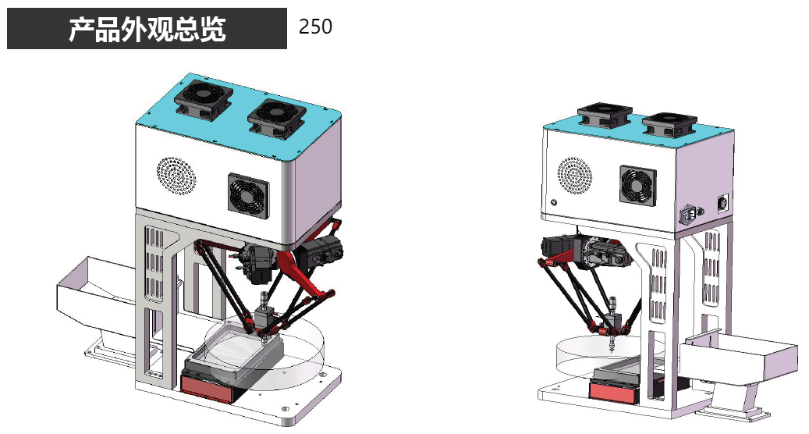

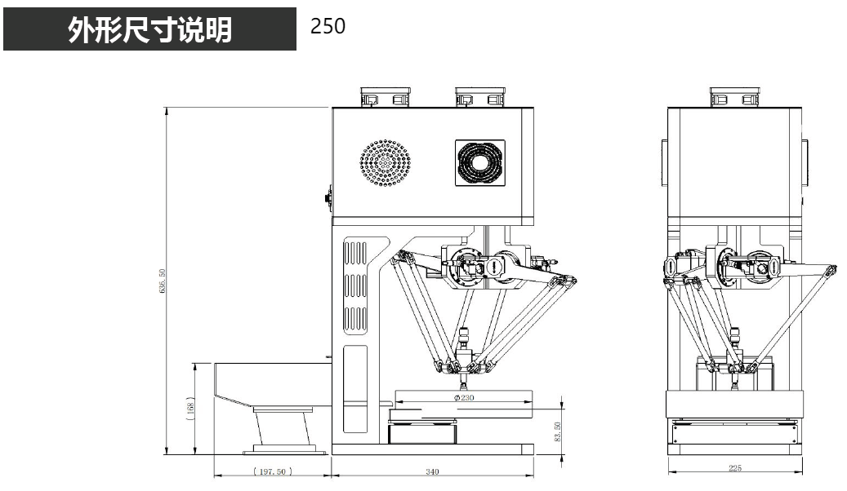

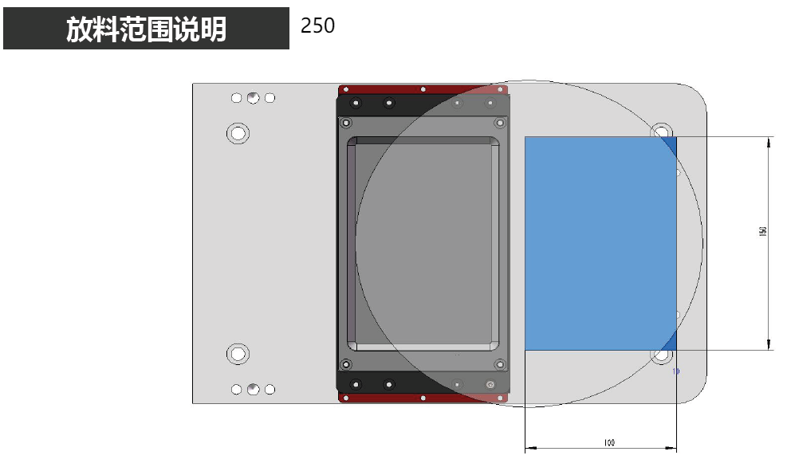

**Model: FA-ZPD300A**

Below is the product introduction and product image:  
**Optical System**: 2 sets of vision systems (flexible vibration bowl positioning camera + fly-by camera)  
**Delta Robot**: 300 mm arm length, 0.5 kg load capacity  
**Vibration Bowl Size**: dimensions 200 x 160 mm  
**Refilling Bin Capacity**: 2L horizontal flow refilling bin  
**Number of Suction Cups**: 1  
**Control System**: Proprietary Spider Hand + vision system + flexible vibration bowl three-in-one control system  
**Plating Speed**: 2500 to 4000 pieces per hour, varying based on product size and correct face probability (plating speed does not include tray change time)  
**Plating Precision**: Without fly-by: ±0.2 mm, With fly-by: ±0.05 mm  
**Plating Range**: 200 x 150 mm  
**Tray Loading Method**: Manual loading and unloading of trays  
**Power Supply**: 220V, 50Hz (110 to 220V converters available)  
**Rated Power**: 2kW  
**Air Pressure**: 0.35 to 0.7 MPa  
**Device Weight**: 300 kg  
**Equipment Dimensions**: 550 mm (length) × 400 mm (width) × 831 mm (height)  
**Operating Temperature**: 0°C to 50°C

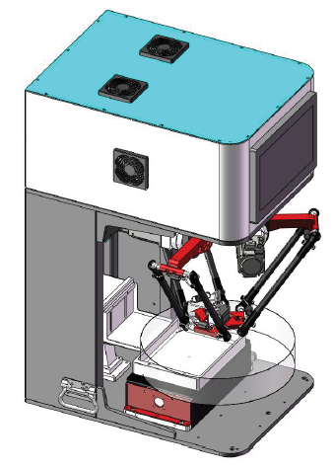

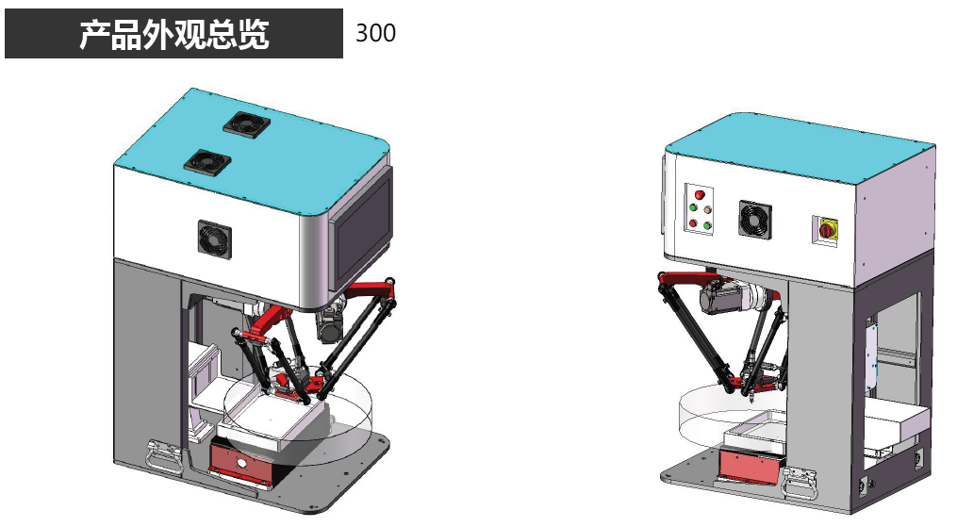

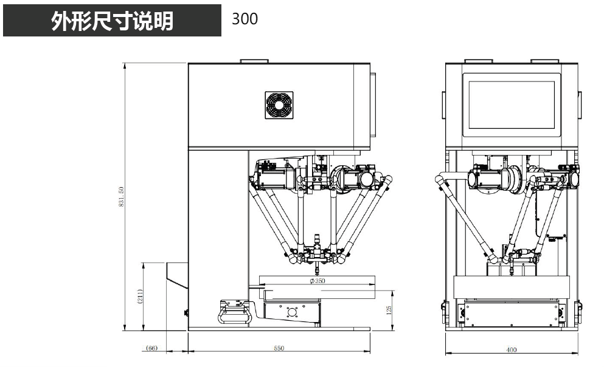

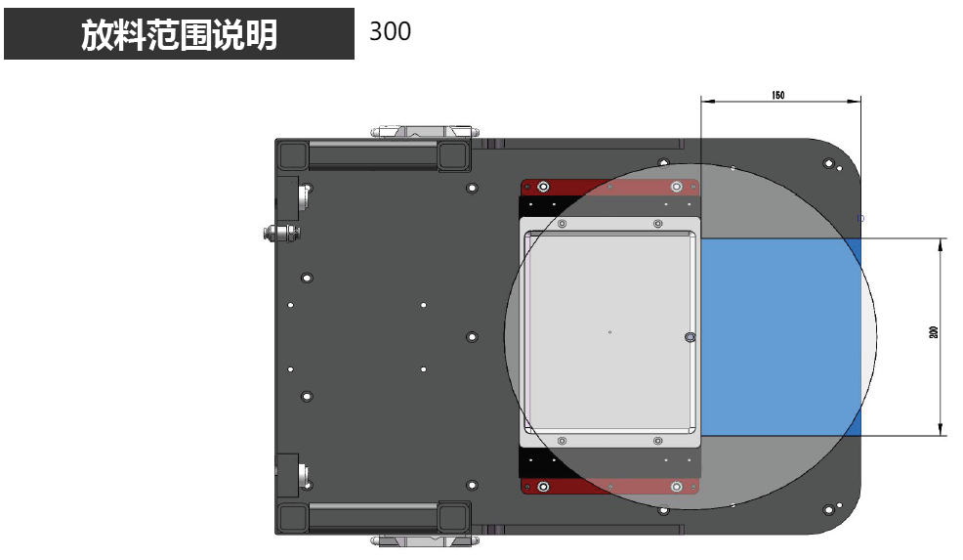

**Model: FA-ZPD400A**

**机型三、FA-ZPD400A（Foxage-Zhizhushou-Put-Disk-400mm工作直径）**

Below is the product introduction and product image:  
**Optical System**: 2 sets of vision systems (flexible vibration bowl positioning camera + fly-by camera)  
**Delta Robot**: 400 mm arm length, 0.5 kg load capacity  
**Vibration Bowl Size**: dimensions 300 x 220 mm  
**Refilling Bin Capacity**: 5L horizontal flow refilling bin  
**Number of Suction Cups**: 1  
**Control System**: Proprietary Spider Hand + vision system + flexible vibration bowl three-in-one control system  
**Plating Speed**: 2500 to 3500 pieces per hour, varying based on product size and correct face probability (plating speed does not include tray change time)  
**Plating Precision**: Without fly-by: ±0.3 mm, With fly-by: ±0.05 mm  
**Plating Range**: 250 x 180 mm  
**Tray Loading Method**: Manual loading and unloading of trays  
**Power Supply**: 220V, 50Hz (110 to 220V converters available)  
**Rated Power**: 2kW  
**Air Pressure**: 0.35 to 0.7 MPa  
**Device Weight**: 300 kg  
**Equipment Dimensions**: 600 mm (length) × 500 mm (width) × 951 mm (height)  
**Operating Temperature**: 0°C to 50°C

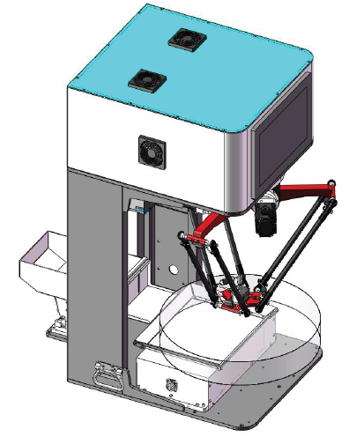

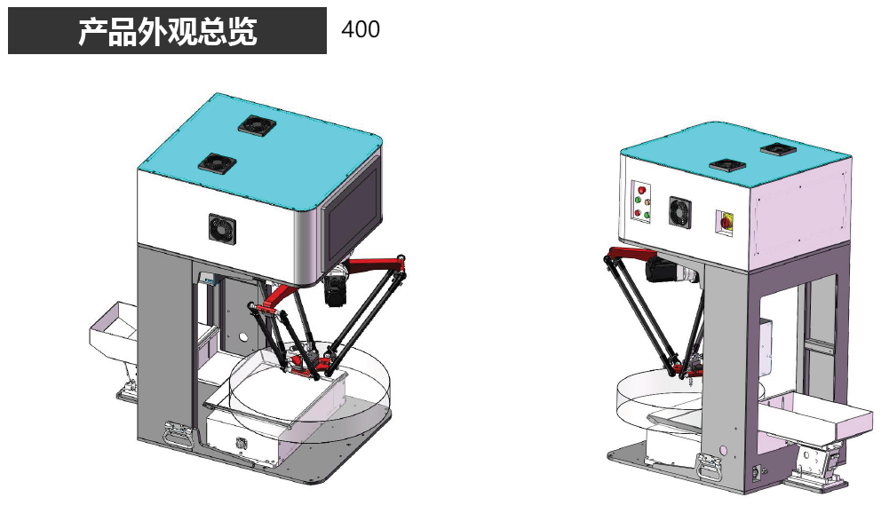

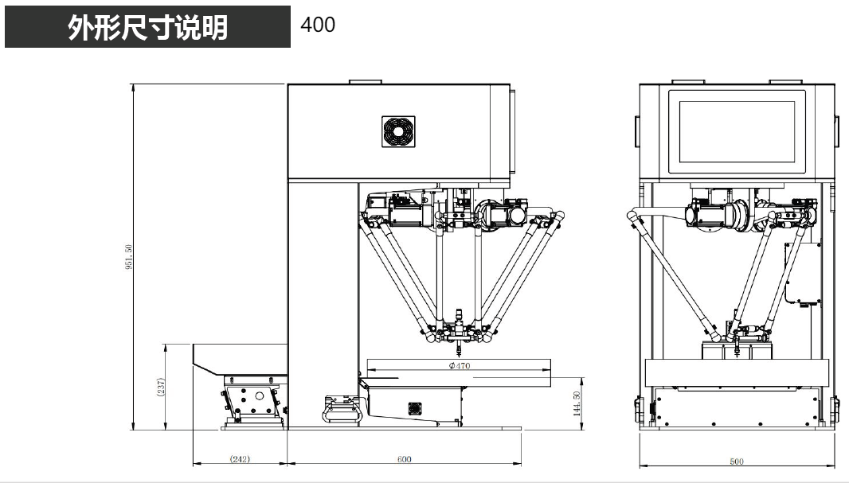

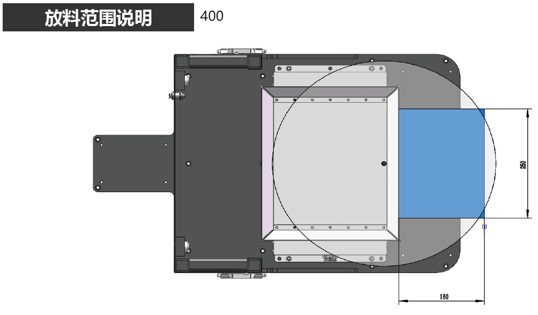

**Model: FA-ZPD500A**

Below is the product introduction and product image:  
**Optical System**: 2 sets of vision systems (flexible vibration bowl positioning camera + fly-by camera)  
**Delta Robot**: 500 mm arm length, 0.5 kg load capacity  
**Vibration Bowl Size**: dimensions 400 x 300 mm  
**Refilling Bin Capacity**: 5L horizontal flow refilling bin  
**Number of Suction Cups**: 1  
**Control System**: Proprietary Spider Hand + vision system + flexible vibration bowl three-in-one control system  
**Plating Speed**: 2500 to 3500 pieces per hour, varying based on product size and correct face probability (plating speed does not include tray change time)  
**Plating Precision**: Without fly-by: +0.3 mm, With fly-by: ±0.05 mm  
**Plating Range**: 350 x 220 mm  
**Tray Loading Method**: Manual loading and unloading of trays  
**Power Supply**: 220V, 50Hz (110 to 220V converters available)  
**Rated Power**: 2kW  
**Air Pressure**: 0.35 to 0.7 MPa  
**Device Weight**: 300 kg  
**Equipment Dimensions**: 600 mm (length) × 500 mm (width) × 951 mm (height)  
**Operating Temperature**: 0°C to 50°C

