Catalog
Chapter I Product Introduction - 1 -
1. Foreword - 1 -
2. Main functions - 2 -
Chapter II Interface Description - 4 -
Chapter III Main Technical Indexes - 7 -
1. Technical specifications of the calibrator - 7 -
2. AC analog small signal output (optional) - 7 -
3. Other indicators - 7 -
Chapter IV Operation Examples - 9 -
1. Wiring instructions - 9 -
2. Software settings - 10 -

Chapter I Product Introduction

Foreword
Power grid companies solve the problems of distribution automation coverage of incremental equipment and mismatch of primary and secondary equipment in large-scale construction and transformation of distribution network, and achieve the goal of simultaneous management of line loss by four divisions (zoning, voltage division, component division and station division), firmly promote the management of line loss by 10 (20/6) kV simultaneous line division, continuously improve the level of lean management of line loss, and enhance the operation of power grid. The primary and secondary integration technical scheme of distribution network equipment is proposed. The most innovative part of the scheme is that the traditional electromagnetic voltage and current transformers are gradually replaced by electronic resistors, capacitors and low-power electromagnetic distribution network AC sensors. The novel power distribution network AC sensor has the advantages of small volume, light weight, strong compatibility and interchangeability, is easy to be made into a voltage and current combined AC sensor, is also convenient to be digitalized and intelligentized, has strong expansibility, and is the development direction of the AC sensor for the future power distribution network.
Distribution network AC sensors (hereinafter referred to as sensors) are divided into voltage sensors, current sensors, and voltage and current combination sensors. Generally, the primary side voltage is 10 (20/6) kV, and the primary side current is 20 A to 600 A. However, for both voltage and current sensors, the secondary side output is weak-mode small-signal voltage, which generally ranges from a few tenths of a volt to a few volts. At present, there is no way to test with the traditional electromagnetic transformer calibrator, and the demand for transformers is very large, and the verification efficiency will directly affect the economic benefits of power supply enterprises. Therefore, our company has independently developed XL-809 electronic transformer calibrator, which is specially used to test this kind of AC sensor. The core of the calibrator adopts dual CPU architecture and has powerful functions. With 24 Bit AD chip and 512 times oversampling technology, the bandwidth is greatly expanded and the measurement accuracy is improved. At the same time, multi-gear automatic switching and FIR filter are used to improve the dynamic range and signal-to-noise ratio. The whole tester is simple and elegant, with touch screen display, touch operation, and USB port to read and export test data.

Main functions
- The test object of XL-809 is the AC sensor conforming to T/ZDG018-2018 Technical Conditions for 10kV and 20kV AC Sensors of Power Distribution Network.
- The measurement of the ratio difference and the angular difference of the AC sensor is realized.
- Display the current primary voltage, current, frequency and other related information to facilitate the comprehensive evaluation of the calibrated parameters.
- Test reference standards include T/ZDG018-2018 Technical Conditions for 10 kV and 20 kV AC Transducers in Power Distribution Network, JJG313-2010 Current Transformers for Measurement and JJG314-2010 Voltage Transformers for Measurement.
- It can display the waveform of the calibrated sensor in real time so as to monitor the waveform distortion of the verified transformer.
- It is convenient to record the error of the verification point, and the recorded error data can be saved by clicking the report generation, which is convenient for archiving or error analysis.
- Large screen display, with touch screen, full Chinese operation prompt, convenient operation, real-time display of measurement data, and statistics, this product has strong adaptability and expansibility, and supports subsequent upgrades.

Chapter II Interface Description
The appearance of XL-809 is as shown in the figure below. The chassis is made of all-aluminum alloy, which is solid, beautiful and light. It is suitable for indoor and outdoor field use. XL-809 simplifies the user's operation details. For wiring, only one tested input and one standard input are needed. It is very simple. There is a handle on the top to facilitate the movement of the device. The following describes all the hardware interface functions of the device.
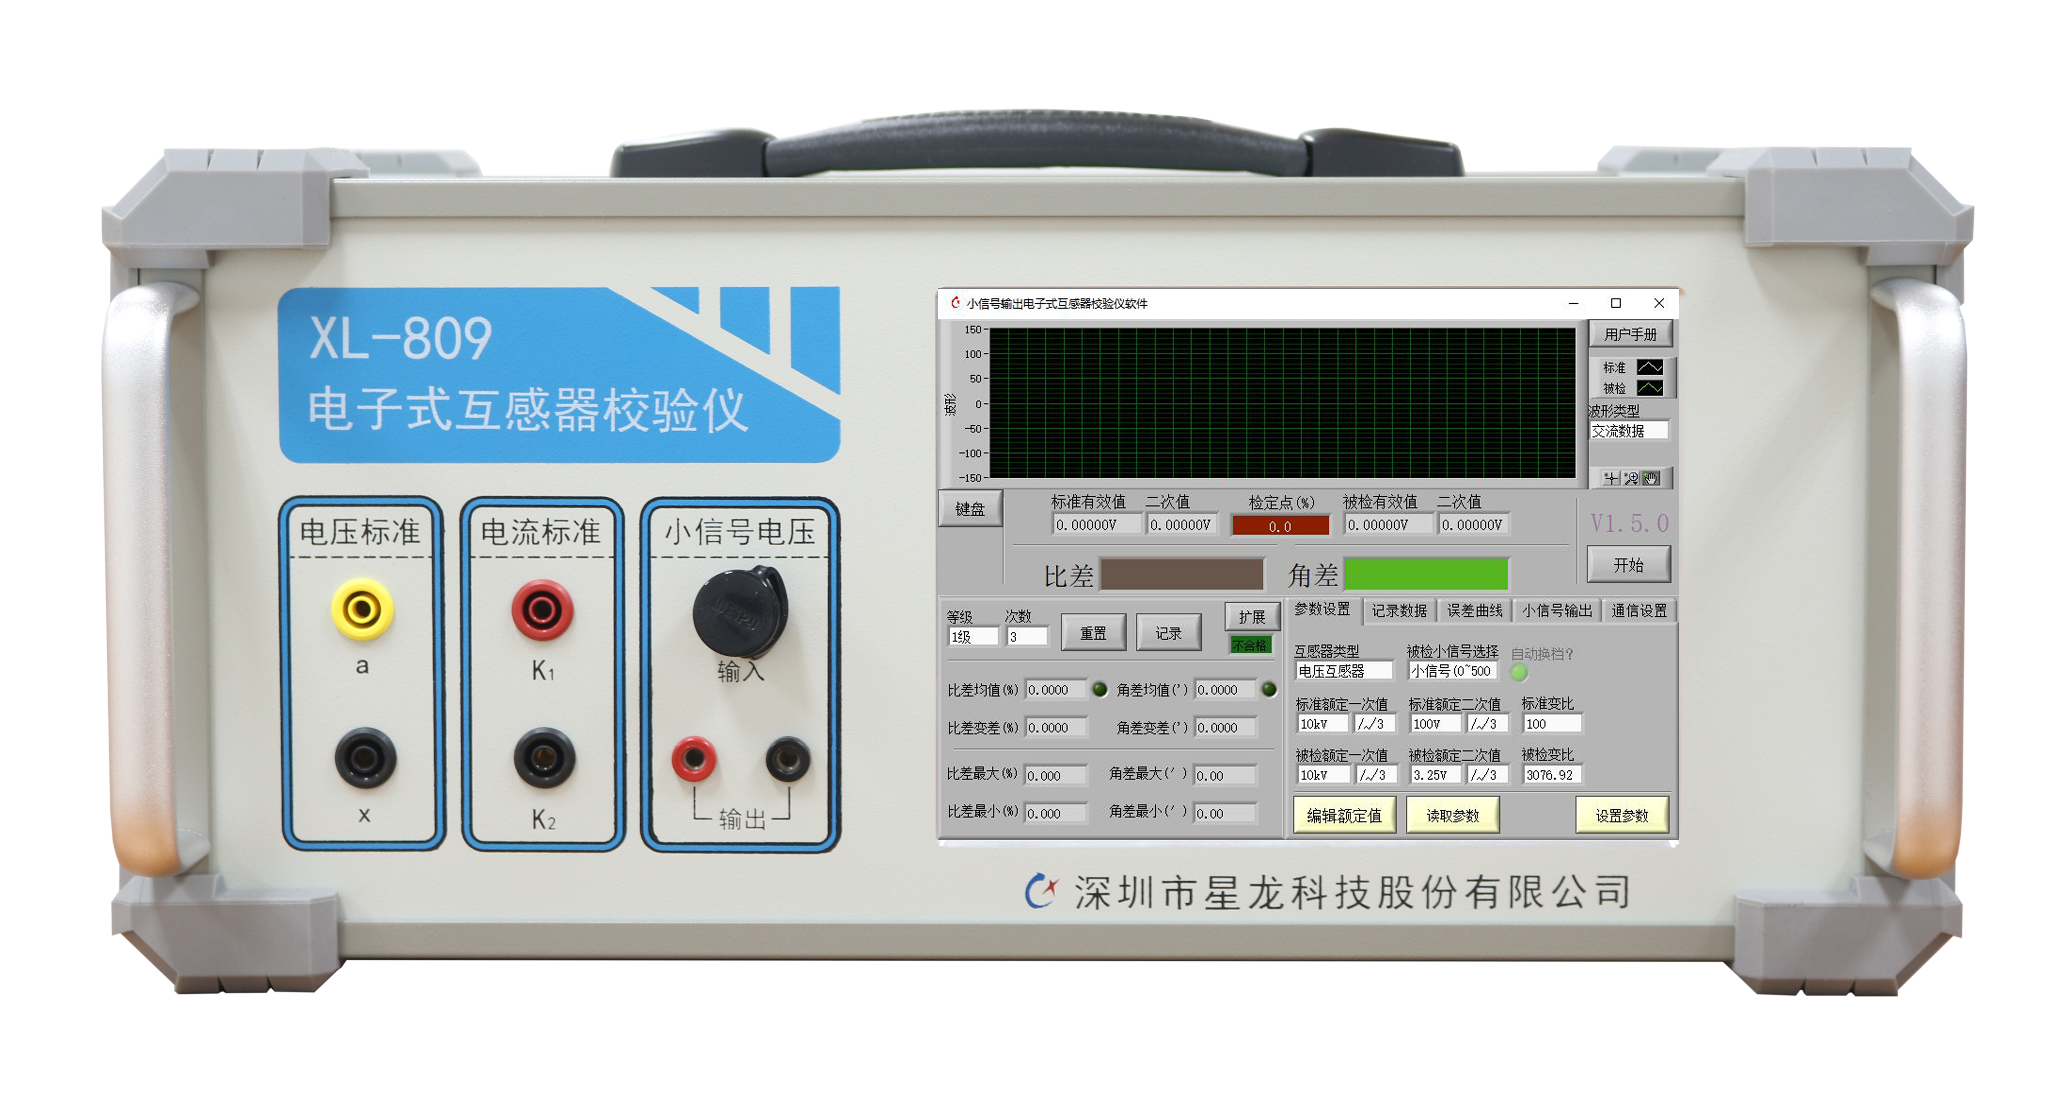

Serial number | Interface name
1 | Signal input port of standard voltage transformer, a is the positive homonymous terminal, and X is the negative homonymous terminal.
2 | Signal input port of standard current transformer: K1 is the positive homonymous terminal, and K2 is the negative homonymous terminal.
3 | The analog small signal input end (connected to the secondary output of AC sensor) shall be connected with the 3-core ohm plug configured by our company. Definition of analog small signal input terminal Ohm line (the first pin is positive, the second pin is negative, and the third pin is not connected).
4 | 0 ~ 7 V AC small signal output port. (Optional)
5 | The industrial personal computer runs the calibration program of the calibrator, and the display is a touch screen, which can be operated by touch.
6 | USB port is used to export data and connect external mouse and keyboard.
7 | Power input: rated value: 220VAC ± 10%, frequency: 50Hz.
8 | The grounding terminal is used to reliably ground the equipment to ensure the safety of electricity.
9 | RS232 serial port: it is the RS232 interface connected with the internal control module of the calibrator, through which it can be connected with the external computer to communicate with the calibrator and control the calibrator.

Chapter III Main Technical Indexes

Technical specifications of the calibrator
Accuracy class of the calibrator | 0.05 grade (ratio error better than 0.05%, angular error better than 2 ′)
Standard Voltage Input Range | 0～120V
Standard voltage measurement range | 20V～120V 0.05%RD 1V～20V 0.1%RD
Standard Current Input Range | 0～6A
Standard current input gear | 50mA、100mA、 1A、 5A
Standard current measurement range | 10mA～6A 0.05%RD
Input range of verified small signal | 0 ~ 8.5V (0 ~ 7V for some old equipment)
Input impedance of verified small signal | 200MΩ

AC analog small signal output (optional)
Output range | 0～7V
Output accuracy | 0.05%RD (200mV～7V)

Other indicators
Working power supply | AC 220V±5% 50Hz
Power consumption of the whole machine | About 30VA
Operating temperature | -10℃～50℃
Relative humidity | ≤ 85% non-corrosive gas
Size | L449mm × W271mm × H182mm
Weight of complete machine | 8.9kg

Chapter IV Operation Examples

Wiring instructions
When using XL-809 electronic transformer calibrator to test AC sensor (voltage sensor is taken as an example in this example), it is required to provide a voltage regulator, booster, standard voltage transformer, tested voltage sensor, several test wires, and load resistance (if the tested sensor needs to be tested under rated load). The test schematic diagram is shown below:
The secondary output of the standard transformer is connected to the standard input port of the calibrator, the positive homonymous terminal is connected to the "a" input port of the calibrator, and the negative homonymous terminal is connected to the "X" input port. Connect the small signal output by the measured voltage sensor to the small signal analog input port.
Note: during the test, it is necessary to strictly ground according to the grounding method in the above figure.

Software settings
- After wiring according to the above wiring diagram, start to set the software. After XL-809 is powered on, open the XL2500 operating software, and select the voltage transformer and standard rating in the parameter setting interface "transformer type".
"Standard rated primary value", "standard rated secondary value", "tested rated primary value", "tested rated secondary value" are set according to the actual sensor being tested. After setting the above parameters, the software will automatically calculate " "Standard transformation ratio" and "tested transformation ratio".
After setting the above parameters, click the "Set Parameters" button to set the parameters. The software interface will display "Parameter Setting Successful". Click the "Start" button to start the test of XL-809.
Slowly rotate the voltage regulator to increase the voltage to each calibration point, and record the test data.

Precautions

1. Please keep a sufficient safety distance during high-voltage testing. The safety distance between 1 and 10 kV is 1.5 meters.

2. The grounding in the wiring diagram is very important. Please ensure that each grounding point is reliably grounded before boosting the voltage.

3. For safety reasons, before powering on the voltage regulator, you must first confirm whether the turntable has returned to zero.

4. When adjusting the voltage regulator, slowly turn the turntable to increase the voltage to the required calibration point.

5. When ending the test or replacing the test sample, reset the voltage regulator to zero, cut off the input power, and use a discharge rod to discharge the high-voltage output part of the booster to ensure safety before removing the wires.

