Catalog
Chapter 1 Product Introduction - 1 -
1. Main features - 1 -
2.Hardware Description - 3 -
3. Main technical indicators - 5 -
Chapter II Operation Examples - 7 -
1.Real load verification - 7 -
2.Virtual load verification - 8 -
3. Virtual verification - 9 -

Chapter 1 Product Introduction

1. Main features
- It has multiple verification modes of virtual load verification, real load verification and virtual verification;
- Communication fault simulation test can be carried out, such as frame loss, channel abnormality, etc., to comprehensively assess the communication function and fault-tolerant ability of the digital electric energy meter;
- Compatible with IEC 61850 -9-1/-9-2/-9-2le protocol, meet the requirements of various optical fiber interfaces, and have self-adaptive capability for communication parameters;
- During real load verification, it can carry out holographic analysis on network message of IEC61850-9-1/IEC61850-9-2/IEC61850-9-2le, such as network address, number of ASDU, sampling rate, data waveform, etc.
- Communication parameters such as the number of ASDU and the number of sampling points can be flexibly configured during virtual verification and virtual load verification;
- Users can edit the automatic verification scheme at will, and our calibrator has provided a variety of verification schemes when leaving the factory;
- With multiple MU modes of single MU, single optical port double MU and double optical port double MU, digital electric energy meters with different wiring modes can be verified;
- Metering devices with ST and SC optical fiber Ethernet interfaces and dual RJ45 electrical Ethernet interfaces to improve communication reliability and facilitate access to different interfaces;
- It has the function of automatically generating reports, and can customize the verification certificate template according to the format required by customers.
- The traditional electric energy reference, such as COM3003 (0.01 level), can be used to achieve precision calibration and traceability.
- Portable design, convenient for field testing, support touch screen and keyboard input;
- The product has strong adaptability and expansibility to meet the needs of future smart substation technology upgrade.

2.Hardware Description
Serial number | Name | Meaning
1 | Voltage input | Input analog quantity for dummy load mode
2 | Current input
3 | Reactive pulse input | Reactive pulse connected to the verified digital electric energy meter
4 | Active pulse input | Access the active pulse of the verified digital electric energy meter
5 | Calibration pulse output | Output the electric energy pulse of the machine and send it for inspection and traceability.
6 | Industrial control computer | Run the calibration software of the calibrator, which can be operated by touch
7 | Optical port 1 (ST fiber) | Receive or transmit SV signals conforming to IEC61850 format
8 | Optical port 2 (SC fiber)
9 | Electrical port 1 (RJ45 network port)
10 | Electrical port 2 (RJ45 network port)
11 | RS232 | Calibrator for external compute communication control
12 | Industrial computer USB | It can be connected to U disk, mobile hard disk and other storage devices to copy data or update programs, or connected to keyboard and mouse to operate industrial computer.
13 | Ground terminal | It is used to reliably ground the equipment to ensure the safety of power consumption.
14 | Power supply input | Access to 220VAC ± 10%, 50Hz mains supply
15 | Industrial computer network port | Used for connecting the industrial computer to the Internet or other data communication
16 | Industrial computer RS232 | Used for IPC communication to control external equipment, or for data exchange

3. Main technical indicators
- Input voltage
Voltage measurement range | 0～120V
Voltage measurement accuracy | (20～100V) 0.05%RD

- Input current
Current measurement gear | 200mA、1A、5A、10A
Accurate measurement range | 50mA～10A 0.05%RD

- Input power measurement
Active power measurement accuracy | 0.05%RD PF=1 （50mA ～ 10A）
 | 0.1%RD PF=0.5L,0.5C （50mA ～ 10A）
Measurement accuracy of reactive power | 0.2%RD PF≥0.5

- Frequency measurement
Frequency measurement range | 45Hz～65Hz
Frequency measurement resolution | 0.001Hz
Frequency measurement accuracy | 0.01Hz

- Electric Energy Measurement
Active energy measurement accuracy | 0.05%RD PF=1 （50mA ～ 10A）
 | 0.1%RD PF=0.5L,0.5C （50mA ～ 10A）
Measurement accuracy of reactive power | 0.2%RD PF≥0.5

- Electrical energy pulse output
Output energy pulse in imp/kWh or imp/kvarh | The settable range is 3600 ~ 2000000 imp/kWh or imp/kvarh, the output is optical isolation output, and the load capacity is not more than 5ma

- Electrical energy pulse input
Input calibrated energy meter pulse (unit: imp/kWh or imp/kvarh) | You can enter a number with a decimal point; Calibration turn setting range: 1 ~ 100, the maximum pulse receiving frequency is 100 Hz

- Other indicators
Operating supply voltage range | AC 220V±5% 50Hz
Power consumption | About 30VA
Warm-up time | < 15 minutes
Operating outside temperature | -10℃～55℃
Relative humidity | ≤85%; Corrosive gas
Size | 470mm×330mm×200mm
Weight of complete machine | 9kg

Chapter II Operation Examples

1.Real load verification
Generally, the real load verification mode is used to verify the digital electric energy meter in the substation site. At this time, the calibrator and the digital electric energy meter receive the IEC61850 protocol frame from the merging unit at the same time, and the electric energy pulse output of the digital electric energy meter is connected to the pulse input port of the calibrator, and the digital electric energy meter can be verified by setting the corresponding parameters.
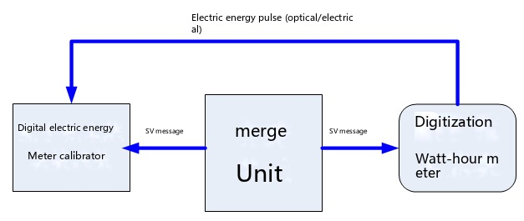
1.1 Click "Actual load verification" to enter the verification interface, as shown in the following figure:
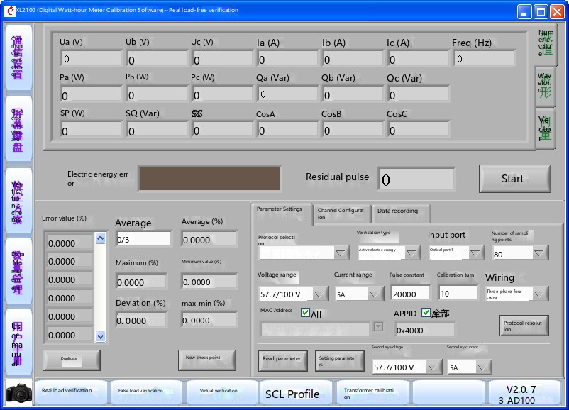
1.2 Set parameters according to the type of the verified digital electric energy meter;
1.3 Click "Start" for verification;
1.4 Record error;

2.Virtual load verification
The standard power source outputs 3U3I analog quantity, the digital electric energy meter calibrator converts the analog quantity into digital quantity conforming to IEC61850-9-1/-9-2/-9-2le through AD, one path is transmitted to the internal standard meter of the calibrator, and the other path is transmitted to the verified digital electric energy meter through Ethernet. The verified digital electric energy meter calculates the electric energy accumulatively according to the received message, the calculated electric energy is fed back to the calibrator through pulse output, and the calibrator calculates the electric energy of the verified digital electric energy meter and the electric energy calculated by the standard meter by comparing the received pulses of the verified digital electric energy meter to obtain the electric energy error of the verified digital electric energy meter. The principle block diagram is shown in the figure below:
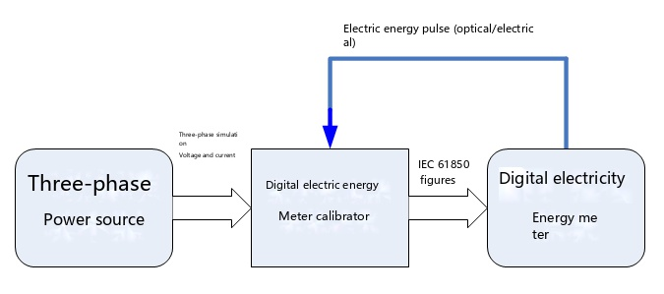

3. Virtual verification
In the virtual verification mode, the calibrator outputs IEC61850 protocol frame, which is transmitted to the verified digital electric energy meter through the network port. This mode does not require a three-phase standard power source. The digital electric energy meter accumulates the electric energy pulse according to the received message, and outputs the accumulated electric energy pulse to the electric energy pulse input port of the calibrator in the form of electric pulse or optical pulse. The calibrator calculates the electric energy of the verified digital electric energy meter by comparing the received pulse of the verified digital electric energy meter with the electric energy calculated by the standard meter to obtain the electric energy error of the verified digital electric energy meter. The principle block diagram is shown in the figure below:
