Catalog

Product introduction - 1 -

1. Main features - 1 -

2. Product attributes - 1 -

2.1 Interface and function description - 2 -

3. Main functions - 3 -

4 Technical indicators - 4 -

5. Other parameters - 5 -

# Product introduction

## Main features

XL-9060 DC watt-hour meter verification device is the latest DC watt-hour meter verification device designed and developed by Shenzhen Xinglong Science and Technology Co., Ltd. In view of the need of DC energy meter verification in the current market, the national standard of DC energy meter is followed, the latest technology is adopted, the main components are imported industrial devices, which can support 0 ~ 60ADC DC current output, 0 ~ 1000V DC voltage output, 0 ~ 5V DC voltage analog shunt output. The accuracy grade of electric energy is better than 0.05%. It also supports the superposition function of voltage and current output ripple, and can be used for virtual load verification and ripple interference test of DC watt-hour meter, or as a separate voltage standard source, current standard source and power standard source.

The device uses 800 × 600 LCD screen, which has clear and simple interface, convenient operation and good visual effect. Waveform quantization adopts 32-bit double modulation output technology to ensure high output precision. The output is safe and reliable with overcurrent and overheat protection.

## Product attributes

Product appearance:

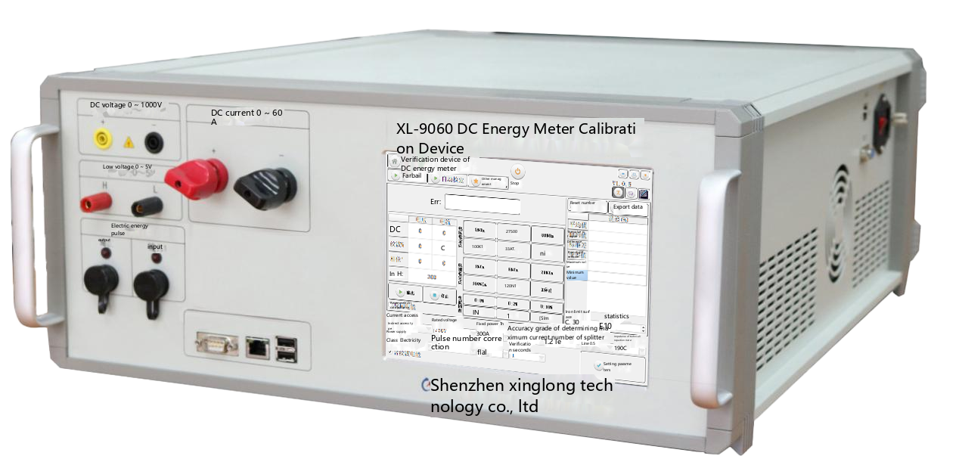



### 2.1 Interface and function description

|  |  |  |
| --- | --- | --- |
| Serial number | Interface name | Functional description |
| 1 | Voltage output terminal | Voltage output terminal block |
| 2 | Current output terminal | Current output terminal block |
| 3 | Small-signal output terminal | 0 ~ 5V small signal output terminal |
| 4 | Pulse output port | Local electric energy pulse output port |
| 5 | Pulse input port | Pulse input port of electric energy meter in corresponding software |
| 6 | Communication serial port | Realizing serial port communication with the industrial personal computer in the equipment |
| 7 | Network port | External network cable interface |
| 8 | USB interface | Mouse, keyboard, storage device, etc. with external USB interface |
| 9 | RJ45 | Ethernet interface |
| 10 | Source communication serial port | The serial port can directly communicate with the bottom control mainboard. |
| 11 | Mains supply connector and switch | Power input switch |
| 12 | Grounding column | Grounding column |

## Main functions

|  |  |
| --- | --- |
| DC voltage output | Support 0 ~ 1000 V DC voltage output, accuracy: < 0.02% |
| DC current output | Support 0 ~ 60 A DC current output, accuracy: < 0.03% |
| Small signal output | Support 0 ~ 5V DC voltage output, accuracy: < 0.03% |
| Error calculation | Support automatic error calculation of upper software |
| Starting test | Support |
| Sneak test | Support |
| Ripple test | Support |
| Generate a report | Support |

## 4 Technical indicators

|  |  |
| --- | --- |
| Electrical energy accuracy class | Grade 0.05 |
| Voltage amplitude accuracy | 0.012% RD ± 0.008% RG (or 10 uV) |
| Current amplitude accuracy | 0.012% RD ± 0.008% RG (or 1 uA) |
| Small signal amplitude accuracy | 0.02% RD ± 0.01% RG (or 2 uV) |
| Power error | <0.05% |
| Number of output phases | 1-phase voltage, 1-phase current, 1-channel small signal |
| Gear setting | Voltage: 100mV, 300mV, 1V, 3V, 10V, 30V, 100V, 200V, 300V, 1000V  Current: 1mA, 3mA, 10 mA, 30 mA, 100mA, 0.3A, 1A, 3A, 10 A, 20A, 60A  Small signal: 1mV, 3mV, 10mV, 30mV, 100mV, 300mV, 1V, 3V, 10V |
| Output stability (/min) | Voltage: better than 0.01% of full scale, 0.005% typical  Current: better than 0.002% of full scale  Small signal: full scale better than 0.01% ± 1uV,  0.01% ± 0.6 uV typical |
| Output Power | Current: < 120VA, port voltage: < 2 V  Voltage: 200 < U ≤ 1150 V: ≤ 25 mA;  10<U≤ 200 V：≤ 100mA；  U≤ 10 V：≤ 10 mA；  Small signal: ≤ 10 mA |
| Long-term stability | Voltage and current: ± 100PPM/year |
| Ripple superposition | Frequency: 20 ~ 500Hz  Ripple factor: voltage: ≤ 20%,  Current and small signal: ≤ 30%  Ripple voltage accuracy: 20-50Hz: < 1%  50-500Hz：<5%  Ripple small signal accuracy: 20-500Hz: < 1% |

## 5. Other parameters

|  |  |
| --- | --- |
| Operating voltage | AC 220V±5% 50Hz |
| Operating temperature | -5 ℃ ~ 40 ℃ Relative humidity: ≤ 80% |
| Storage temperature | -25℃～75℃ |
| Weight of complete machine | About 21 kg |
| Volume of the whole machine | 379mm×590mm×199mm |
| Cooling method | Air Cooling |
| Noise | <60dB |